Physical Activity During Growth

Effects on Bone, Muscle, Fracture Risk   
and Academic Performance

Jesper Fritz

LundUniv_ENG_C2line_Black

DOCTORAL DISSERTATION

by due permission of the Faculty of Medicine, Lund University, Sweden.  
To be defended at Ortopedens Föreläsningssal, Inga Marie Nilssons gata 22, Malmö, January 13, 2017, at 09.00.

*Faculty opponent*Professor Mats Börjesson  
Gymnastik och Idrottshögskolan Stockholm and Sahlgrenska akademin Göteborg

|  |  |  |  |
| --- | --- | --- | --- |
| Organization  LUND UNIVERSITY  Clinical and Molecular Osteoporosis Research Unit Department of Clinical Sciences | | Document name  DOCTORAL DISSERTATION | |
|  | | Date of issue  January 13, 2017 | |
| Author(s)  Jesper Fritz | | Sponsoring organization | |
| Title and subtitle  Physical Activity During Growth – Effects on Bone, Muscle, Fracture Risk and Academic Performance | | | |
| Abstract  Physical activity (PA) enhances bone mass, bone structure and muscle strength, traits associated with low fall and fracture risk. Since the greatest effect of PA on musculoskeletal health occurs during childhood, increased PA for all children could be a strategy to improve these traits. Since PA may also influence brain development, cognition and concentration, it has been postulated that physical activity may enhance academic performance.  The Pediatric Osteoporosis Prevention (POP) study is a population-based prospective controlled exercise intervention study with one school as intervention school and three other schools as control schools. In the intervention school we increased the amount of physical education (PE) per week from the Swedish standard of 60 minutes to 200 minutes. Meanwhile, the control schools continued with 60 minutes of PE per school week.  We included all children (aged 6–8 years) who started first grade in these schools from 1998 to 2012 and followed them for seven years regarding fractures, using our digital radiographic archive (*cohort A – 3,534 children*). Children starting school between 1998 and 2000 were invited to musculoskeletal evaluations during seven years, using dual-energy X-ray absorptiometry (DXA) for bone parameters such as areal bone mineral density (aBMD), peripheral quantitative computed tomography (pQCT) for bone structure such as cortical thickness, and computerized dynamometer (Biodex) for muscle strength (evaluated by isokinetic peak torque) (*cohort B – 261 to 264 children depending on evaluated trait*). To evaluate academic performance, we included all children who finished 9th grade from 2003 to 2012 in all of Sweden (*cohort C – 1,161,807 children*) and in the intervention school (*cohort D – 633 children*) and evaluated the grade scores and eligibility for upper secondary school programs in both cohorts. We could thus compare the academic results within and between the groups before the intervention was initiated (finished school in year 2003 to 2006) and with the intervention (finished school in year 2007 to 2012).  The incidence rate ratio (IRR) of fractures in the intervention group compared to the control group decreased with each year of the intervention (r=–0.79; p=0.036). Girls in the intervention group gained more spine aBMD during the seven-year study period (p<0.05) and had higher cortical thickness (p<0.05) after seven years intervention than girls in the control group. Both girls and boys in the intervention group gained more muscle strength than their respective control group (p ranging from <0.05 to <0.01). With the intervention, the proportion of boys eligible for upper secondary school increased by 7.3 (1.4, 13.2) percentage points (pp) and the overall grade points increased by 13.3 (3.1, 23.5) points among boys.  This thesis concludes that a long-term PA intervention program initiated in pre-pubertal children reduces the fracture risk with each year of intervention, and improves skeletal traits in girls, muscle strength in both genders and academic performance in boys. | | | |
| Key words  Academic performance, Children, Fracture risk, Muskuloskeletal traits, Physical activity | | | |
| Classification system and/or index terms (if any) | | | |
| Supplementary bibliographical information | | | Language  English |
| ISSN and key title  1652-8220 | | | ISBN  978-91-7619-384-6 |
| Recipient’s notes | Number of pages 85 | | Price |
|  | Security classification | | |

I, the undersigned, being the copyright owner of the abstract of the above-mentioned dissertation, hereby grant to all reference sources permission to publish and disseminate the abstract of the above-mentioned dissertation.

Signature Date

Physical Activity During Growth

Effects on Bone, Muscle, Fracture Risk   
and Academic Performance

Jesper Fritz

LundUniv_ENG_C2line_Black

Financial support for this study was received from ALF, Region Skåne FoUU, Centre for Athletic Research (CIF), Herman Järnhardt Foundation, Greta och Johan Kock’s Foundation, Maggie Stephen’s Foundation, Skåne University Hospital (SUS) Foundations and Clinical Osteoporosis Research School (CORS).

|  |
| --- |
| Copyright Jesper Fritz  Clinical and Molecular Osteoporosis Research Unit  Department of Clinical Sciences and Orthopedics  Skåne University Hospital, Malmö  Faculty of Medicine, Lund University, Sweden  ISBN 978-91-7619-384-6  ISSN 1652-8220  Lund University, Faculty of Medicine Doctoral Dissertation Series 2017:3  Printed in Sweden by Media-Tryck, Lund University  Lund 2017 |

# Content

Abstract 7

Abbreviations 9

Original Papers 10

Glossary 11

Introduction 13

Fractures 13

Skeleton 15

Physiology 15

Growth, peak and decline 18

Bone strength 19

Risk factors 20

Measurements 20

Muscle 24

Physiology 24

Muscle strength 25

Measurements 25

Academic School Performance 26

Physiology 26

Measurements 28

Physical activity 29

Falls and Fractures 29

Skeleton 30

Muscle 31

Academic School Performance 31

Adverse effects 32

Aims 37

General 37

Specific 37

Hypothesis 39

Research questions 41

Material and methods 43

The Pediatric Osteoporosis Prevention (POP) study 43

Fracture registration 44

Measurements 45

Academic performance 51

Statistical methods 52

Summary of papers 53

Paper I 53

Paper II 54

Paper III 55

Paper IV 56

General discussion 57

Osteoporosis and fracture risk 57

Musculoskeletal traits 60

Academic performance 61

Strengths of the studies 63

Limitations of the studies 64

Conclusions 65

Future perspectives 67

Summary in Swedish – Populärvetenskaplig sammanfattning 69

Acknowledgements 71

References 73

## Abstract

Physical activity (PA) enhances bone mass, bone structure and muscle strength, traits associated with low fall and fracture risk. Therefore PA has been suggested as a strategy to improve musculoskeletal health in the population to decrease the incidence of one of the largest and most costly health problems in the world, osteoporosis and related fractures. Since the greatest effect of PA on musculoskeletal health occurs during childhood, and since there is no clinically useful way of knowing who will develop osteoporosis later in life, increased PA for all children could be a strategy to decrease osteoporosis in the population of future generations. Speaking of future generations, since PA may also influence brain development, cognition and concentration, it has been postulated that physical activity may enhance academic performance. Since the proportion of Swedish children who finish the 9th and final year of compulsory school without eligibility for upper secondary school programs has increased during recent decades, increased PA in school could also be a strategy to reverse this negative trend. Previous prospective pediatric PA intervention studies are short-term, use specific training programs and only use surrogate endpoints both for fractures and academic performance. The Pediatric Osteoporosis Prevention (POP) study is a population-based prospective controlled exercise intervention study, designed to evaluate the effect of PA on musculoskeletal development, fracture risk and academic performance in children. This thesis presents the outcome after 7–9 years of the program.

In the POP study, one school was chosen as intervention school and three other schools in the same area with the same socioeconomic background were chosen as control schools. In the intervention school we increased the amount of physical education (PE) per week from the Swedish standard of 60 minutes to 200 minutes, given as one lesson of 40 minutes for each of the five school days per week. Meanwhile, the control schools continued with 60 minutes of PE per school week.

We included all children (aged 6–8 years) who started first grade in these schools from 1998 to 2012 and followed them for seven years regarding fractures, using our digital radiographic archive (*cohort A – 3,534 children*). Children starting school between 1998 and 2000 were invited to annual lifestyle and musculoskeletal evaluations during seven years, using questionnaire for lifestyle factors, dual-energy X-ray absorptiometry (DXA) for bone parameters such as areal bone mineral density (aBMD), peripheral quantitative computed tomography (pQCT) for bone structure such as cortical thickness, polar strength strain index (SSI) and cortical bone mineral mass distribution in several tibial sites, and computerized dynamometer (Biodex) for muscle strength (evaluated by isokinetic peak torque) (*cohort B – 261 to 264 children depending on evaluated trait*). To evaluate academic performance, we included all children who finished 9th grade from 2003 to 2012 in all of Sweden (*cohort C – 1,161,807 children*) and in the intervention school (*cohort D – 633 children*) and evaluated grade scores and eligibility for upper secondary school programs in both cohorts. We could thus compare the academic results within and between the schools before the intervention was initiated (finished school in year 2003 to 2006) and with the intervention (finished school in year 2007 to 2012).

The incidence rate ratio (IRR) of fractures in the intervention group compared to the control group decreased with each year of the intervention (r=–0.79; p=0.036) and during the seventh year it was almost halved (IRR 0.52 95% CI 0.27, 1.01). Girls in the intervention group gained more spine aBMD during the seven-year study period (p<0.05) and had higher cortical thickness (p<0.05) and greater SSI (p<0.05) at the 66% tibia site after seven years intervention than girls in the control group. In girls in the intervention group these enhancements were accompanied by greater mineral mass in the lateral, anterior-medial and medial sectors of the tibia both at the 66% and the 38% sites (p ranging from <0.05 to <0.001) than controls. We found no skeletal differences between intervention and control boys. Both girls and boys in the intervention group gained more muscle strength than their respective control group (p ranging from <0.05 to <0.01). With the intervention, the proportion of boys eligible for upper secondary school increased by 7.3 (1.4, 13.2) percentage points (pp) and the overall grade points increased by 13.3 (3.1, 23.5) points among boys. This resulted in both higher eligibility rate (+8.3 pp) and higher overall grade points (+12.6 points) in the intervention school compared to all other Swedish boys. Among girls, the academic school performance did not change with the intervention.

This thesis concludes that a long-term PA intervention program initiated in pre-pubertal children reduces the fracture risk with each year of intervention, and improves skeletal traits in girls, muscle strength in both genders and academic performance in boys.

## Abbreviations

aBMD Areal bone mineral density (g/cm2)

ANCOVA Analysis of covariance

BMC Bone mineral content (g)

BMD Bone mineral density (g/cm2)

BMI Body mass index (kg/m2)

CI Confidence interval

CV Coefficient of variation (%)

DPA Dual-photon absorptiometry

DXA Dual-energy X-ray absorptiometry

Ex Extension

Fl Flexion

FN Femoral neck

IRR Incidence rate ratio

LS Lumbar spine

PA Physical activity

PBM Peak bone mass

PE Physical education

POP Pediatric Osteoporosis Prevention (study)

pQCT Peripheral quantitative computed tomography

RCT Randomized controlled trial

SD Standard deviation

SPA Single-photon absorptiometry

SSI Polar strength strain index

TB Total body

vBMD Volumetric bone mineral density (g/cm3)

WHO World Health Organization

## Original Papers

1. **The Associations of Physical Activity with Fracture Risk – a 7 year Prospective Controlled Intervention Study in 3 534 Children**

Fritz J, Cöster ME, Nilsson J-Å, Rosengren BE, Dencker M, Karlsson MK.

*Osteoporosis International 2016, 27:915–922*

1. **A Seven-year Physical Activity Intervention for Children Increased Gains in Bone Mass and Muscle Strength**

Fritz J, Rosengren BE, Dencker M, Karlsson C, Karlsson MK.

*Acta Paediatrica 2016, 105:1216–1224*

1. **Influence of a School-Based Physical Activity Intervention on Cortical Bone Mass Distribution: A 7-year Intervention Study**

Fritz J, Duckham RL, Rantalainen T, Rosengren BE, Karlsson MK, Daly RM.

*Calcified Tissue 2016, 99:443–453*

1. **Daily School Physical Activity Improves the Academic School Performance in Boys but not Girls – a Nine-year Nationwide Prospective Controlled Intervention Study**

Fritz J, Cöster ME, Rosengren BE, Karlsson C, Karlsson MK.

*In manuscript*

## Glossary

Accuracy In this context means how well a measured value corresponds to the true value

Concentric contraction A contraction during shortening of the muscle

Eccentric contraction A contraction during lengthening of the muscle

Exercise Physical activity that is planned, structured with repetitive bodily movement performed to improve or maintain one or more components of physical fitness

Isokinetic Movement at a constant angular velocity around the axis of rotation

Isometric contraction A contraction during which the muscle length remains unchanged

Muscle strength The amount of force that can be produced by a muscle in a single contraction

Peak torque Maximum force applied around a pivot point

Physical activity Any bodily movement produced by the contraction of skeletal muscles that result in energy expenditure

Polar distribution Subdivision of the cortex into sectors around its center of mass with the average bone mass estimated for each sector

Pre-pubertal children Children in Tanner stage 1 or 2

Radial distribution Subdivision of the cortex into concentric rings with the average bone density estimated for each ring

Reliability Refers to the consistency of measurements

Validity The extent to which an instrument or method actually measures what it is intended to measure

# Introduction

## Fractures

The rising number of fractures in elderly is a large health problem worldwide, especially in populations with a high incidence of osteoporosis1. Fractures result in individual disability, non-autonomy, and death2,3 and large costs for society4. With the projected increase in life expectancy, especially in developing countries1, the problem of fractures in elderly will grow even bigger in the future5,6. In Sweden, the lifetime risk of sustaining an osteoporosis-related fracture is roughly 50% for women and 25% for men, one of the highest incidences in the world7,8. Furthermore, it has recently been shown that the distal forearm fracture rate in children is currently 50% higher than in the 1950s, and it still appears to be increasing9. So, how can we prevent fractures? Well, there are several risk factors for fractures that could be addressed. One, of course, is low bone mass, which is the cornerstone of the osteoporosis diagnosis. Other important risk factors are low muscle strength, susceptibility to falls, benzodiazepines, other psychotropic drugs and impaired vision10. Body mass index (BMI) has long been considered a protective factor for fracture risk in adults11, especially for hip fractures, but recent research has shown that BMI also acts as a risk factor for proximal humerus fractures12.

Fractures are also a great problem in magnitude during childhood, since 10–25% of all pediatric injuries include fractures13 and close to half of all boys and around one third of all girls will sustain a fracture during growth14,15. Pediatric fracture incidence has also been shown with time trends, indicating that there has been an increase in fracture risk from 1998 to 200716 (Figure 1).

Figure 1. Pediatric fracture incidence from 1993 to 200716.

Fracture risk in children peaks during early puberty, possibly due to high bone turnover, with a large gain in bone size but slower bone mineral accrual, temporarily leaving the bone more fragile17. The most common fracture sites in children and adolescents are the distal forearm, followed by the hand14. Some risk factors for fracture in children are the same as for elderly, e.g. low bone mass18 and low muscle strength19, while others are prevalent only in children, e.g. vigorous physical activity20.

With this in mind, any intervention or treatment leading to a decreased number of fractures mediated through increased bone mass, bone strength, muscle strength or other factors should be of profound interest both now and in the future.

## Skeleton

### Physiology

Bone is a tissue with vascularization and innervation that constantly remodels to adapt to the needs of the skeleton. The hard building block of the skeleton consists of the hydroxyapatite molecule, Ca5(PO4)3(OH)2, while the triple helix protein of collagen type 1 together with several glucosaminoglycans make up the extracellular matrix that surrounds the cellular components of the bone. There are three main types of bone cells, osteoblasts, osteoclasts and osteocytes. They work in units called basic multicellular units (BMU), where the osteoblasts produce new bone and the osteoclasts resorb bone21. The third cell type, the osteocytes, are embedded in bone matrix during new bone formation, connected to each other with long dendrites and make up roughly 90% of all skeletal cells in adults22. The function of osteocytes is not completely understood, but they are believed to be mechanosensible, capable of transducting mechanical stimuli to a biological response in bone23. The mechanosensible process has been postulated to be regulated by cilia, projected from the cell surface, allowing the dynamic fluid flow created by movement to affect the cilia and thereby altering the cellular activity24.

There are two types of bone tissue: compact (cortical) and cancellous (spongy) bone. In compact bone, the bone matrix and osteocytes are histologically organized in onion-shaped rings called osteons with a central canal, called the Haversian canal, containing blood vessels, lymphatic tissue and sometimes nerves. Osteocytes lie in small cavities, called lacunae, and are connected to each other by small tunnels called canaliculi21 (Figure 2). In compact bone, the Haversian systems are packed tightly together, almost as a solid mass while the cancellous bone is lighter and less dense. Cancellous bone consists of plates (trabeculae) and bars of bone adjacent to small, irregular cavities that contain red bone marrow. The canaliculi connect to the adjacent cavities, instead of a central Haversian canal, to receive their blood supply.

Figure 2. The anatomy of bone tissue25.

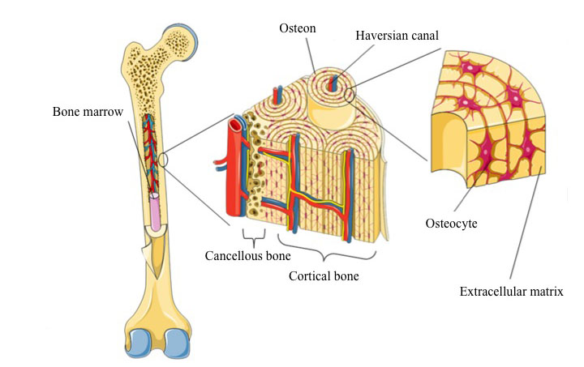

The bones of the body come in a variety of sizes and shapes. The four principal types of bones are long, short, flat and irregular. Long bones consist of a long shaft (diaphysis) with two bulky ends (epiphysis). They are primarily compact bone but may have a large amount of cancellous bone in the epiphysis (Figure 3). Long bones include bones of the thigh, leg, arm, and forearm. Short bones are roughly cube shaped and consist primarily of spongy bone, which is covered by a thin layer of compact bone. The bones of the wrist and ankle are short bones. Flat bones are thin, flattened, and usually curved, and the cranium consists primarily of flat bones. Bones that are not in any of the above three categories are classified as irregular bones. They are primarily spongy bone that is covered with a thin layer of compact bone, e.g. the vertebrae.

Figure 3. The anatomy of a long bone.

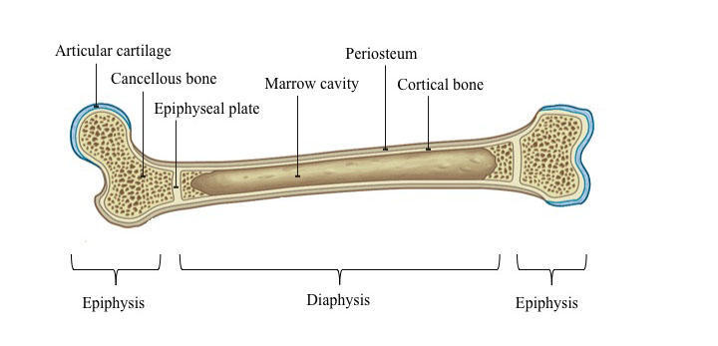

There are two types of metabolic processes in bone tissue, bone modeling and bone remodeling. Bone modeling is when the metabolism changes the shape and size of the skeleton and takes place during growth, but can also be seen later in life in response to mechanical loading or during fracture repair. Bone remodeling is when old bone is substituted for new bone without changing the shape and size of the bone and is an ongoing process in adult life26, replacing approximately 25% of the cancellous bone and 3% of the cortical bone each year27.

Protection is one of several main functions of the skeleton. Some bones, such as the rib cage and skull, protect vital organs from injury, while others, such as the femur, protect the bone marrow. Another main function of the skeleton is mechanical support, whereby bones provide a framework for the attachment of muscles and other tissues. Within this framework, some bones act as levers enabling movement as a result of muscle contraction. Storing calcium is yet another purpose of bone. The calcium levels are of most importance for the bone-building capacity and are closely linked to the parathyroid hormone (PTH), calcitonin and vitamin D levels. PTH increases the blood calcium levels by increasing bone resorption (through increased osteoclastic activity) and also increases reabsorption of calcium in the kidneys. Calcitonin counteracts these effects. PTH also increases the enzymatic activation of vitamin D in the kidneys, which increases calcium absorption from the intestines, tubular reabsorption in the kidneys and skeletal calcium release28. This means that over-production of PTH in the parathyroid glands leads to elevated bone remodeling and thereby decalcification of the skeleton, while elevated calcium levels in the blood have the opposite effect29. Vitamin D is essential for calcium uptake in the intestines and calcium resorption from bone and it increases both the osteoblastic and ostoclastic activity, leaving the skeleton intact30. Vitamin D is converted from 7-dehydrocholesterol to metabolically active vitamin D3 (cholecalciferol) when our skin is exposed to sunlight and it can also be ingested. Since vitamin D has a positive effect on bone and also seems to have a direct effect on skeletal muscle to reduce the risk of falling, at least in elderly people, vitamin D may have the potential to reduce fracture risk31.

### Growth, peak and decline

Growth hormone (GH) and Insulin-like Growth Factor-1 (IGF-1) stimulate the differentiation and proliferation of osteoblasts and are thereby the two main regulators of gains in bone mineral content (BMC) before puberty32. Up until puberty the gain in BMC is linear in both girls and boys33. At puberty the levels of sex steroids increase, raising the levels of GH and IGF-1, and all three of these hormones have an anabolic effect on bone and muscle tissue34. Girls hit their peak velocity of growth about 1.5 years earlier than boys (mean age of 11.8 in girls and 13.4 in boys) and about one year later peak bone mineral accrual occurs35. During the two years around peak bone mineral accrual, approximately 25% of an individual’s bone mineral is achieved, a similar amount is later lost during the 50–60 years of life remaining after peak bone mass35,36. Hence, puberty is an important period in life when it comes to bone growth, probably as a result of the skeleton being maximally responsive to stimuli during periods with fast skeletal apposition37. During puberty the possibility to influence the skeleton is therefore greater, both in a positive way with physical activity8,38 and in a negative way through malnutrition39.

Peak bone mass (PBM) is the highest bone mass a person reaches during lifetime, and is usually reached in the early twenties and varies depending on gender, genetic background and skeletal region40, being as early as age 17–18 years in the hip41 and as late as age 40 in the distal forearm42. Genetic factors regulate 50–85% of the variance in PBM43, but other factors such as energy intake, protein intake, calcium intake and level of physical activity contribute as well44,45.

After PBM, the skeleton gets weaker with age42, resulting in an exponentially increased fracture risk46,47, and when a certain point in this skeletal deterioration is reached we call it “osteoporosis”. Since low bone mineral density is associated with fracture risk independent of trauma level and therefore an important factor48, this point has been defined by the World Health Organization, (WHO), as 2.5 or more standard deviations (SD) lower BMD (bone mineral density) than the mean value of young healthy adults of the same gender, also referred to as T-score –2.5 (Table 1). Since bone fragility and greatly increased fracture risk is the major clinical manifestation, osteoporosis is also “a systemic skeletal disorder characterized by low bone mass and micro-architectural deterioration of bone tissue” according to WHO49. Primary osteoporosis is the result of aging, menopause and/or lifestyle factors without any underlying disease, while secondary osteoporosis is, at least partly, due to an underlying disease50.

PBM has been suggested as the single most important factor in the development of osteoporosis40,51, and since a 10% increase in PBM is predicted to delay development of osteoporosis by 13 years51 and up to half of the variance in bone mass at age 70 is estimated to be predicted by PBM52, this does not seem farfetched.

Table 1. The WHO definition of osteoporosis by use of T-score 49.

|  |  |
| --- | --- |
| Stage | Definition |
| Normal bone mineral density | BMD T-score above –1 SD |
| Osteopenia | BMD T-score –1 to –2.5 SD |
| Osteoporosis  Severe osteoporosis | BMD T-score < –2.5 SD  Osteoporosis and at least one fracture related to osteoporosis |

T-score refers to the number of standard deviations (SD) below or above the mean value of young health adults of the same gender

### Bone strength

Bone strength or the resistance to mechanical failure sets the bar for “the force required to produce mechanical failure under a specific loading condition”53 and depends on both the mechanical and structural properties of the bone54. But what is mechanical failure?

When a force is applied to a bone it is absorbed and stored in the bone through bone deformation. A force lower than the yield point of the bone will not change the original shape of the bone after the release of the force. Any force greater than the yield force will cause micro damage and deformation. Further increase of the force will eventually reach the breaking point of the bone, causing a fracture, that is, separating the bone into two or more fragments. There are several properties of the bone that influence bone strength, such as bone geometry, trabecular and cortical architecture, degree of mineralization and bone turnover. Skeletal architecture, geometry and size contribute to the skeletal resistance to loading independently of BMD42,55, clinically illustrated by the fact that women with femoral neck fractures have smaller femoral neck but normal vertebral size compared to controls, and women with spine fractures have smaller vertebrae but normal femoral neck size compared to controls55,56.

Loading of the long bones is normally axial or bending compression. Compression is the shortening of the bone as an axial force acts upon it. Tension gives a lengthening of a bone, hence when a bending force acts on bone it will be compressed on one side while tension acts on the other side. This can induce localized cortical bone adaptations to resist fractures at sites subjected to the greatest loads57. The mass and density of cortical bone varies across its cross-section and along its axial length, and inter-individual differences likely reflect adaptations that occur in response to increased (or decreased) loading58,59. During growth, bone modeling is the primary factor associated with exercise-induced changes in cortical bone geometry and mass distribution around the center of mass or neutral axis (polar distribution)60. In contrast, any variation in cortical density and its circumferential distribution (radial distribution) are likely to be related to changes in intra-cortical remodeling that alter the porosity and/or mineralization of bone61,62.

### Risk factors

The most important risk factor for osteoporosis is natural aging, an unalterable risk factor that over time leads to an increasing fracture risk independent of the level of BMD. Other similar risk factors are gender, ethnicity and age at menopause, all of which are also risk factors for fracture and falls. Since hereditary and lifestyle factors influence the level of BMD, several other risk factors have been found through research within these areas, including genetic variance that explains the disease63,64 and also modifiable risk factors such as low body mass, smoking, alcohol consumption, inferior nutrition, physical inactivity, cortisone treatment, low sun exposure, vitamin D deficiency and inadequate calcium consumption.

### Measurements

Bone mass is an unscientific term, generally meaning an estimation of bone mineral, either BMC or BMD. BMC is the amount of mineral (g) measured within a scanned skeletal region, BMD, from here on referred to as areal BMD (aBMD), is the amount of mineral partially adjusted for bone size (g/cm2) through a defined scanned area and volumetric BMD (vBMD) (g/cm3) takes length, width and depth into account when estimating bone density. aBMD is clinically used as it is a reasonable predictor of fragility fracture in adults65, while BMC and bone size should be reported separately in children since their bones constantly increase in size66. For example, an increase in bone size with unchanged amount of mineral would result in an unchanged BMC while aBMD would decrease. When the accrual of mineral and gain in bone size are similar, the BMC increases and the aBMD remains unchanged. Only when the relative accrual of mineral is greater than the gain in bone size does the aBMD increase.

Most methods for estimating the mineralization of bone use ionizing radiation while others are non-ionizing (Table 2). Magnetic Resonance Imaging (MRI) and ultrasound are examples of non-ionizing methods. The techniques utilizing ionizing radiation depend on either gamma radiation or X-rays67 but all use the amount of ionizing radiation absorbed by the bone to estimate the amount of mineral. Dual-energy X-ray absorptiometry (DXA) and peripheral quantitative computed tomography (pQCT) are the most common techniques in this group today.

Table 2. Examples of methods for measuring bone mineral.

|  |  |  |
| --- | --- | --- |
| Non-Ionizing | Ionizing | |
|  | *Gamma Radiation* | *X-ray* |
| Quantitative Ultrasound  (QUS) | Single Photon Absorptiometry (SPA) | Single X-ray absorptiometry  (SXA) |
| Magnetic Resonance Imaging (MRI) | Dual Photon Absorptiometry (DPA) | Dual-Energy X-ray Absorptiometry (DXA) |
|  |  | Peripheral Computed Tomography (pQCT) |

#### Dual-energy X-ray absorptiometry (DXA)

DXA (Figure 4) uses an X-ray generator as radiation source and a filter to send out two different energy levels68. By measuring the radiation on the other side of the individual, using a detector, the absorbed radiation and the bone, muscle and fat mass can be calculated in this two-dimensional image. DXA has been available since 1987 and has replaced previous techniques, such as single photon absorptiometry (SPA), dual photon absorptiometry (DPA) and single X-ray absorptiometry (SXA). DXA is considered the “gold standard” for the diagnosis of osteoporosis and is the most frequently used method in osteoporosis research69,70. DXA can measure any body part and uses a relatively low radiation dose (1–8 µSv), which corresponds to 1/1000 of the yearly background radiation dose71. The accuracy of DXA is about 10% (measuring a vertebra)72 and the precision of the technique is 0.5–2%73.

Figure 4. Dual energy X-ray absorptiometry (DXA) scanner. *Photo by Nick Smith photography (ALSPAC)*.

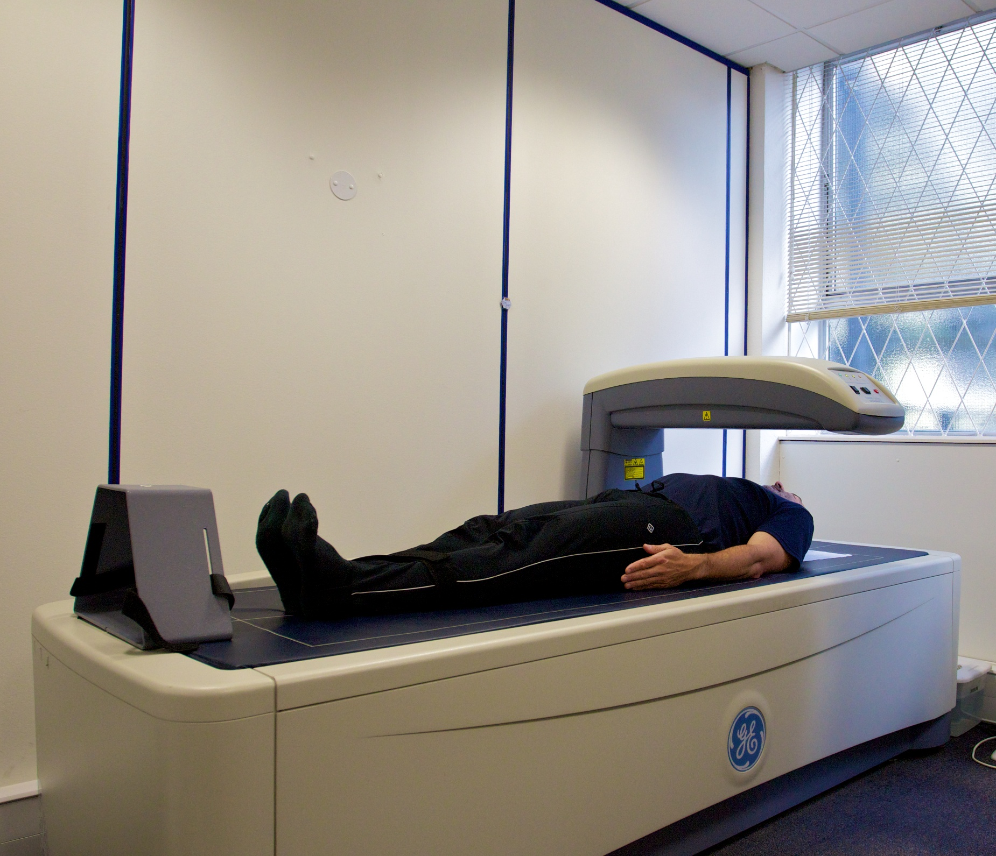

#### Peripheral quantitative computed tomography (pQCT)

Quantitative computed tomography (Figure 5) uses a higher radiation dose than DXA71. In children, only peripheral images, usually at the tibia or radius, are acceptable, as the radiation dose in these parts remains under 10 µSv71,74. This technique creates a virtual three-dimensional image, enabling visualization of the microarchitecture and distribution of bone and soft tissue. This also enables calculation of bone parameters such as mineral mass, vBMD, cortical thickness and strength strain index (SSI), supplying even more information regarding bone strength and resistance to fracture.

Figure 5. A peripheral quantitative computed tomography (pQCT) apparatus, (XCT 2000 Stratec® Pforzheim).

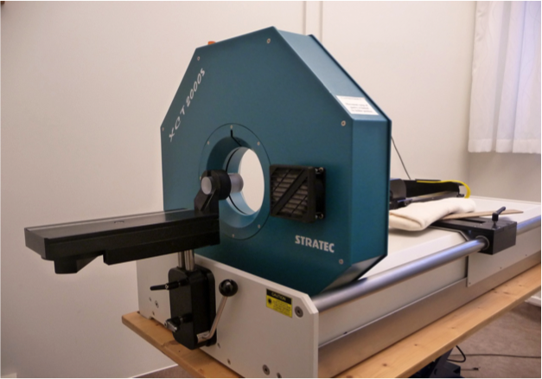

## Muscle

### Physiology

Muscular tissue is built from muscle fibers, where each fiber contains thousands of thin strands, called myofibrils. Two overlapping protein filaments, actin and myosin, constitute myofibrils, and it is the interaction between actin and myosin that produces muscular contraction75 (Figure 6). Each muscle fiber is innervated by a single motor neuron, but each neuron can innervate thousands of muscle fibers. The fiber size increases 5–10-fold during growth, probably depending on workload76. There are two types of muscle fibers, type I and type II. Type I fibers are slow-twitch, use aerobic metabolism, where PA leads to energy expenditure and hydrolysis of adenosine triphosphate (ATP), and are dependent on the supply of creatine phosphorus (CK)75,77. Type II fibers are fast-twitch, are only in use during strenuous or very rapid activation, use anaerobic metabolism generating less energy and more lactate than type I fibers, and are dependent on oxygen access in the mitochondria77,78. Genetics largely determines the distribution of the two muscle fiber types, and conversion between type I and type II fibers is rare79.

Figure 6. The anatomy of a muscle fiber.

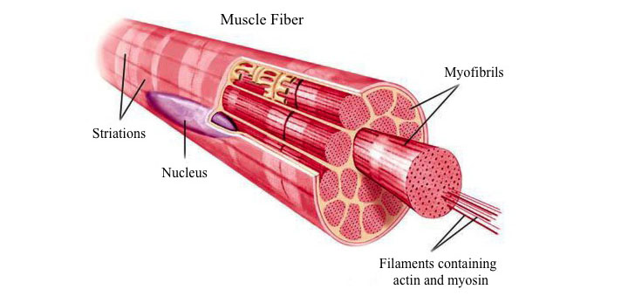

There are three types of muscle contractions, concentric, eccentric and isometric. Concentric contraction is a contraction during shortening of the muscle, eccentric contraction is a contraction during elongation of the muscle and isometric contraction is a contraction during which the muscle maintains its length. During any motion all three types of contractions usually occur simultaneously in different muscle groups80.

### Muscle strength

Defined as “the amount of force that can be produced by a muscle in a single contraction”, muscle strength reflects the tension created when actin slides past myosin filaments within the muscle fibrils80. In children, muscle strength is associated with age, height and/or body stature, weight, gender and sexual maturity81,82. Before puberty, muscle strength seems to increase in a linear fashion without associated muscle hypertrophy, while resistance training and gains in muscle strength are associated with muscular hypertrophy in adolescent boys83. In other words, in early childhood optimized neuromuscular function seems to be the mechanism behind exercise-induced increase in muscle strength, while hypertrophy becomes a factor during adolescence.

### Measurements

A common way to measure muscle strength is by the use of isokinetic dynamometers in knee extension and flexion, measuring the highest peak torque in the quadriceps muscles (extension) and the hamstrings muscles (flexion) at the strongest point during the movement around the axis of rotation84. There is however a need for further research to determine the validity of this much-used method in children85. Another method with high specificity is to utilize standardized weights during isotonic strength measurement, but this method is limited as it measures the maximum strength at the weakest point in the motion range86.

## Academic School Performance

### Physiology

The brain and the spinal cord constitute the central nervous system (CNS). Together with the peripheral nervous system (PNS) it can relay information to and from the brain to different parts of the body, thus allowing movement and sensory input. The brain is the body’s control center, constantly receiving and interpreting nerve signals from the body, and it responds based on this information87. The largest part of the brain, the cerebrum, is divided into two hemispheres, where the right hemisphere controls the left side of the body and the left hemisphere controls the right side of the body. The outer surface of the cerebrum is called the cerebral cortex or gray matter. It is the area of the brain where nerve cells (neurons) make connections, called synapses. Neurons might not be replaced or repaired if they are damaged. The inner area of the cerebrum, called the white matter, contains the insulated (myelinated) bodies of the nerve cells (axons) that relay information between the brain and spinal cord (Figure 7).

Figure 7. Cross section visualisation of the brain, with its gray (cortex) and white matter. *Figure by NIH Medline.*

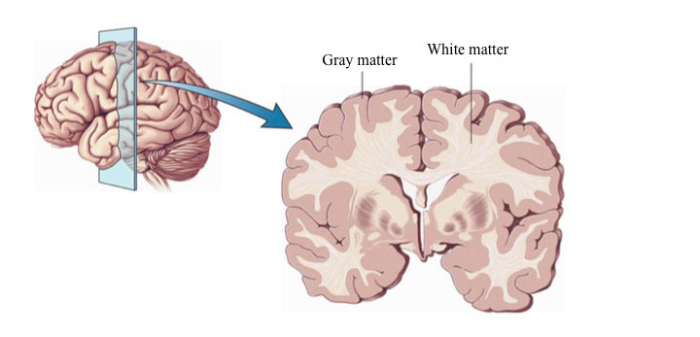

The cerebrum is further divided into 4 sections on each side, called the frontal, parietal, temporal and occipital lobes (Figure 8). The frontal lobe is thought to control movement, speech, behavior, memory, emotions and intellectual functioning, such as thought processes, reasoning, problem solving, decision making and planning. The parietal lobes on the other hand seem to control sensations, such as touch, pressure, pain and temperature, and also spatial orientation (understanding of size, shape and direction). The temporal lobes are responsible for hearing, memory and emotions and the left temporal lobe also most often controls the speech. Vision has been found to be represented mainly in the occipital lobes87.

Figure 8. The lobes of the brain.

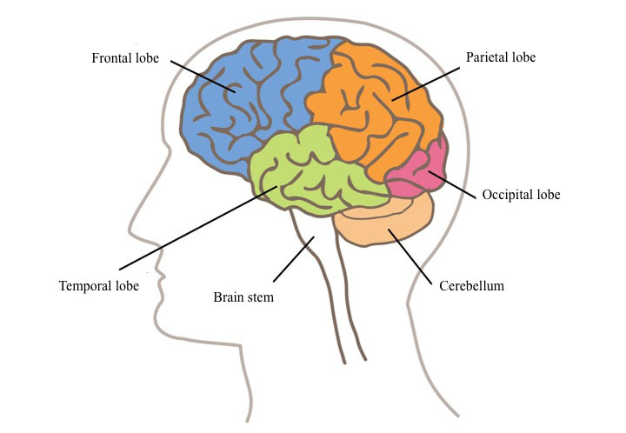

Concentration is an overall control of thoughts and actions through focus, endurance and attention of the mind88,89. Learning ability is closely connected to concentration, and neither has a specific anatomical location in the brain or body. Several factors have been postulated to affect concentration and academic performance, such as the support and availability of the parents, socio-economic level, parental education and PA90-92. During recent decades there has been a trend of decreasing school results in several western countries93 and therefore it should be considered an international issue.

### Measurements

The most common way to evaluate academic performance is through grades or grade point average (GPA). Within this system, different countries use different grading systems, some use numbers (e.g. 1–6) and others use letters (e.g. A–F)94. In Sweden there have been several different grading systems in use just during the last century. From 1897 to 1962 there was a seven-step grading system utilizing capital and small letters from a to c, either as single letters and as combinations. Then there was a five-step system using the numbers 1 to 5. In 1994, Sweden changed to a four-step system including the grades; Failed (0 points), Passed (10 points), Passed with Distinction (15 points) and Passed with Special Distinction (20 points), as a combined name- and points-system. Finally, in 2013 Sweden switched back to a letter-based grading system, this time running from A to F in six steps95.

Another measurement for academic performance on a general level is the proportion of children with eligibility for upper secondary school programs. To qualify for national upper secondary school programs in Sweden the grade Passed in each of the subjects Swedish, English and Mathematics was required from 1994–2012. During recent decades the proportion of Swedish children who finished the 9th and final year of the compulsory school with eligibility for upper secondary school programs has decreased96,97. The proportion of eligible students was only 86% in 2015, the lowest proportion since 199896. The decrease is a paradox since researchers claim that 100% of Swedish pupils have the potential and capacity to reach the goals for a pass grade in all school subjects98.

## Physical activity

The most commonly used definition of physical activity is “any bodily movement produced by the contraction of muscle that results in energy expenditure”99. Over millions of years, humans, like most other animals, have adapted to survive in an environment where our survival is dependent on our ability to move. Lack of movement, or physical activity, has been associated with diseases and early death100-103. Technical advances, such as transportation, large food supplies and computers decrease our need to be physically active, resulting in increasingly sedentary lives.

Measuring or estimating physical activity with accuracy is difficult. The most commonly used method is self-report by various questionnaires104,105 with the obvious limitation of subjectivity but with the advantage of low-cost and ease to administer. Doubly labeled water (DLW), heart rate monitors (HRM), pedometers and accelerometers are all objective measurements but have different limitations including high cost and no information about intensity, duration or frequency for the DLW106, influence of emotional stress, body size, temperature, age and fitness level for HRM107, no information about intensity and duration for pedometers108 and lack of registration in water and with activities without relative positional change, such as cycling, for accelerometers.

During recent decades there has been a reduction in physical education (PE) in school in favor of academic subjects109. In Sweden PE has been reduced from 20% to 7.5% during the most recent three decades110. Also, only six out of 28 countries in Europe offered at least 180 min/week of PE in school111. PA pattern during adulthood, however, seems moderately reflected by PA behavior during childhood112-114, providing arguments enough for increased level of PA in children.

### Falls and Fractures

Several fall-prevention programs have shown a fall-reductive effect in randomized controlled trials (RCT)115-118, including programs with different approaches such as physical exercise, home hazard modifications, adjustment of psychotropic medication, modification of multi-pharmacy and anti-slip shoe devices. Falls account for about 15% of vertebral fractures and 90% of hip fractures119 and fall-preventive interventions should therefore be provided in a structured approach to the elderly, especially high-risk groups, to reduce the number of falls and fallers120. Many guidelines suggest that all women above 65 years should be screened for osteoporosis, using DXA, the fracture risk assessment tool FRAX® or both, to detect individuals at high risk of sustaining a fragility fracture, in order to treat osteoporosis with bisphosphonates or other antiresorptive agents121,122. If presenting one or more risk factors, women should be screened at a younger age123, while the benefits of screening men are still debated123,124.

Movement increases the risk of falling and sustaining injuries. During childhood the appendicular skeleton initially grows rapidly while BMC lags behind, resulting in a relative increase in skeleton size compared to mineralization, rendering a reduction in aBMD. This means a temporarily more fragile skeleton, with the peak in childhood fracture risk at age 11 in girls and age 14 in boys14,125. Since coordination usually is less developed during this period, increased movement or exercise could result in increased fracture risk20. Most studies investigating the long-term effect of exercise during youth or adult life indicate improved bone mass, structure and resistance to fracture126, leaving an open debate between increased short-term fracture risk and long-term musculoskeletal benefits.

### Skeleton

In 1987, Dr. Harold Frost proposed the idea that bone adapts to the mechanical stress it is exposed to127. The notion that the effects of exercise on bone are age- and maturity-dependent, where the late pre- and early pubertal years (Tanner stage 2 and 3) seem to be a “window of opportunity” to influence bone at a maximum level through PA38,128, is supported by several RCTs and non-randomized controlled exercise interventions (Table 3), and the skeletal response to exercise is smaller in adults than in children and adolescents. To produce the most pronounced skeletal response, the load of the exercise should be fast, dynamic, high in magnitude with unusual or abnormal strains and intermittent resting periods included between sessions129,130, such as weight lifting, tennis, hockey and soccer131. Smaller effects have been observed in long-distance runners132,133 whereas no or minimal effects have been shown in endurance sports without weight bearing, such as swimming and cycling133. It has also been shown that the skeletal response to exercise is regional and site-specific37,134. Muscles are responsible for a large portion of the load and strains on bone, and it has been demonstrated that the increase in bone parameters during growth and in response to exercise is to a large extent mediated through muscle tissue135, even though muscle area could explain only 12–16% of the variance in bone mass, size and bending strength136.

Several studies have shown that exercise-induced skeletal benefits during growth remain in adulthood137,138, even after reduction or even discontinuation of sports activities139. This highlights that exercise during growth may either lay the foundation for a physically active lifestyle or result in skeletal benefits that are retained in older ages112-114.

### Muscle

PA does not only stimulate cross-sectional growth of the muscle fibers, mitochondrial biogenesis, synthesis of oxidative enzymes and excitation-contraction coupling improvements, but also stimulates increased recruitment of muscle units, neoangiogenesis and coordination benefits140. In line with the type I fibers using aerobic metabolism and type II fibers using anaerobic metabolism, endurance training with multiple repetition with low loads improves the type I fibers through increased mitochondrial oxidative chain capacity, whereas resistance training with low repetition frequency and increased loads has a greater impact on type II fibers and muscle strength through muscle cross-section hypertrophy141-143. Hence, there are benefits to both training modalities, and the aim and genetic potential of the individual determines the best individual exercise program.

While several studies have reported a marked increase in the effect of training on muscle mass in males compared to females during late puberty, most probably due to androgen effects on protein synthesis144,145, a meta-analysis evaluating the effects of resistance training on muscle strength in children and adolescents showed that the possibility to gain muscle strength seems to increase with maturation and age, but without a clear boost during puberty146. Whether there is a “window of opportunity” to gain muscle strength during puberty is therefore still debated.

### Academic School Performance

High level of PA has been associated with better intellectual performance91,92. Some studies infer that PA may have direct positive effects on the nervous system by increasing brain volume, blood flow to the brain, synaptic plasticity, as well as promoting formation of nerve cells, all involved in different aspects of perception, cognition, memory and attention147-150. Other studies suggest that PA has positive effects on psychological parameters such as self-esteem, motivation, social engagement and communication, all of importance for learning outcomes109. There are even studies suggesting that inferior motor skills might lead to negative effects in these psychological parameters and delay cognitive development151,152. Furthermore, reports also show an association between PA and attention and academic test results153,154, a link between higher levels of PA and the ability to concentrate in the classroom, which also could be of importance for academic achievement. Few studies have addressed the hypothesis and most have included small samples, been short-term and used different surrogate endpoints for academic performance155-157, possibly explaining the divergent conclusions. Since no intervention studies with prospective controlled study design are available and those only few of the others have used the clinical relevant endpoint “eligibility for upper secondary school programs” and none has been made on a national level, there is no consensus on the effect of increased PA on academic school performance.

### Adverse effects

Since most falls and fractures in young age occur during movement, an adverse effect of PA could be increased fall and fracture risk. Previous research shows that vigorous PA, including gymnastics, swimming, aerobics, running, dancing, netball or similar activities, is associated with high fracture risk in children20.

Another possible adverse effect of increased PA is the female athlete triad, defined as the combination of disordered eating, amenorrhea and osteoporosis, possibly resulting in premature osteoporotic fractures and permanent loss of aBMD158.

Table 3. Exercise intervention trials and their effect on skeletal traits in children.

|  |  |  |  |  |
| --- | --- | --- | --- | --- |
| Reference | Age and Number of Participants | Type of Exercise/PA | Study Duration | Effects on Bone Increase, higher in Cases vs. Controls |
| Tanner stage 1 – Pre-pubertal | | | | |
| Gunter et al.  2008 | 22 girls 34 boys 7–8 years | High-moderate impact jumps  20 min ×3/week | 7 months | BMC: FN |
| Wiebe et al. 2008 | 42 girls 6–10 years | High-moderate impact jumps  50 min ×3/week | 7 months | aBMD: No effects |
| Bradney et al. 1998 | 38 boys 10.4±0.4 years | Weight bearing 30 min ×3/week | 8 months | aBMD: TB, LS, Legs CT: Legs |
| MacKay et al. 2000 | 144 children 6.9–10.2 years | High-moderate impact  10–30 min ×3/week | 8 months | aBMD: Tr |
| Fuchs et al. 2000 | 99 children 7.6±0.2 years | High impact jumping | 7 months | BMC: FN, LS aBMD; LS, BW: FN |
| Petit et al 2002 | 68 children 10.0±0.6 years | High impact  10–12 min ×3/week | 7 months | No effects |
| Van Langendonck et al. 2003 | 42 children 8.7±0.7 years | High impact ×3/week | 9 months | BMC: PF, FN |
| Specker et al.  2003 | 178 girls 3.9±0.6 years | High impact 30 min ×5/week | 12 months | BMC: Legs |
| MacKelvie et al.  2004 | 64 boys 10.2±0.2 years | High impact 10–12 min ×5/week | 20 months | BMC: FN HSA: Z |
| Laing et al. 2005 | 143 girls 10.2±0.2 years | Gymnastics 60 min /week | 24 months | BMC: TB, LS, PF aBMD: TB, PF BA: TB, PF |
| Valdimarsson et al.  2005 | 103 girls 7.7±0.6 years | PE classes 40 min ×5/week | 12 months | BMS: Tr, LS |
| Linden et al.  2006 | 99 girls 7.6±0.6 | PE classes 40 min ×5/week | 24 months | BMC: LS, Legs,  aBMD: TB, LS, Legs BW: LS |
| Linden et al.  2007 | 138 boys 7.8±0.6 years | PE classes 40 min ×5/week | 24 months | BMC: LS, Legs,  aBMD: TB, LS, Legs BW: LS |
| Alwis et al.  2008 | 137 boys 7.8±0.6 years | PE classes 40 min ×5/week | 24 months | BMC: LS BW: LS |
| Alwis et al.  2008 | 99 girls 7.6±0.6 years | PE classes 40 min ×5/week | 24 months | HSA: No effects |
| Hasselström et al.  2008 | 349 children 6.8±0.4 years | PE classes 45 min ×2/week | 36 months | Girls BMC: Distal forearm BA: Distal forearm Boys No effects |
| Greene et al.  2009 | 42 girls 6–10 years | High-moderate impact jumps 50 min ×3/week | 7 months | HSA: No effects |
| Meyer et al.  2011 | 158 children 8.7±2.1 years | PE classes 45 min including 10 min of jumping ×2/week | 9 months | BMC: TB, LS, FN |
| Tanner stage 2–3 – Early pubertal | | | | |
| Morris et al. 1997 | 71 girls 8.7±2.1 years | Moderate impact 30 min ×3/week | 10 months | BMC: TB; LS, FN, PF aBMD: TB, LS, FN |
| Heinonen et al.  2000 | 58 girls 11.0±0.9 years | High impact 20 min ×2/week | 9 months | BMC: LS, FN |
| MacKelvie et al.  2001 | 107 girls 11.0±0.9 years | High impact 10–12 min ×3/week | 7 months | BMC: LS aBMD: LS, FN |
| Petit et al.  2002 | 106 girls 10.5±0.6 years | High impact 10–12 min ×3/week | 7 months | aBMD: Tr, FN HSA: Z CT: FN |
| Iuliano-Burns et al.  2003 | 64 girls 8.8±0.1 years | Moderate impact 20 min ×3/week | 9 months | BMC: LS, Lower leg |
| MacKelvie et al.  2003 | 75 girls 9.9±0.6 years | High impact 10–12 min ×3/week | 20 months | BMC: FN, LS |
| McKay et al.  2005 | 122 children 10.1±0.5 years | Jumping 3×3 min ×3/week | 8 months | BMC: PF, Tr,  BA: PF HSA: No effects |
| Courteix et al.  2005 | 113 girls 8–13 years | Exercised mean 7.2 hours /week vs. 1.2 hours /week | 12 months | aBMD: TB, LS, FN |
| Macdonald et al.  2008 | 197 girls 213 boys 10.2±0.6 years | High impact 15 min ×5/week | 11 months | Girls BMC: FN Boys BMC: LS, TB HSA: Z |
| Löfgren et al.  2011 | 92 girls 131 boys 7.8±0.6 years | PE classes 40 min ×5/week | 36 months | Girls BMC: LS, FN BW: LS HSA: CSA Boys BMC: LS BW: LS HSA: No effects |
| Meyer et al.  2011 | 133 children 11.1±0.6 years | PE classes 45 min including 10 min of jumping ×2/week | 9 months | BMC: TB, LS, FN |
| Löfgren et al.  2012 | 96 girls 125 boys 7.8±0.6 years | PE classes 40 min ×5/week | 36 months | Girls BMC: TB, LS, FN, Tr BW: LS, FN HSA: CSA, Z, CSMI Boys BMC: LS BW: FN HSA: No effects |
| Tanner stage 4–5 – Late pubertal | | | | |
| Blimkie et al. 1996 | 36 girls 16.3±0.3 years | Weight training ×3/week | 7 months | No effects |
| Witzke et al.  2000 | 53 girls 14.6±0.5 years | Resistance training 30–45 min ×3/week | 9 months | No effects |
| Heinonen et al.  2000 | 68 girls 13.3±0.9 years | High impact 20 min ×2/week | 9 months | No effects |
| Nichols et al.  2001 | 67 girls 15.9±0.1 years | Resistance training 30–45 min ×3/week | 15 months | aBMD: FN |
| Sundberg et al.  2001 | 104 girls 122 boys 16.0±0.3 years | PE classes 40 min ×4/week | 48 months | Girls No effects Boys BMC: FN, Spine aBMD: FN |
| Stear et al.  2003 | 144 girls 17.3±0.3 years | Moderate impact 45 min ×3/week ± calcium | 16 months | BMC: LS, TB, PF, Tr |
| Weeks et al. 2003 | 44 girls 37 boys 13.8±0.4 years | High impact jumping 10 min ×2/week | 8 months | Girls BMC: FN, LS Boys BMC: TB, LS, Tr QUS: BUA |
| Detter et al.  2013 | 96 girls 125 boys 7.9±0.6 years | PE classes 40 min ×5/week | 60 months | Girls BMC: FN aBMD: Spine Size: FN area Boys aBMD: Spine |
| Detter et al.  2014 | 130 girls 165 boys 7.9±0.6 years | PE classes 40 min ×5/week | 72 months | Girls BMC: FN aBMD: Spine Size: FN area Boys aBMD: Spine |
| Fritz et al.  2016 | 117 girls 147 boys 7.7±0.6 years | PE classes 40 min ×5/week | 84 months | Girls aBMD: Spine CT: TCT Boys No effects |
| Fritz et al.  2016 | 116 girls 145 boys 7.7±0.6 years | PE classes 40 min ×5/week | 84 months | Girls CT: SSI, MM, vBMD Boys No effects |

Significant increase in intervention compared to controls seen in the parameters/sites: Bone area (BA), Bone width (BW), Broadband ultrasound attenuation (BUA), Cross-sectional area (CSA), Cross-sectional moment of inertia (CSMI), Computed tomography (CT), Distal forearm, Femoral neck (FN), Hip structure analysis (HSA), Lumbar spine (LS), Mineral mass distribution (MM), Proximal femur (PF), Stress strain index (SSI), Total body (TB), Tibial cortical thickness (TCT), Trochanter (Tr), Volumetric bone mineral distribution (vBMD), Section modulus (Z).

# 

# Aims

### General

To prospectively evaluate the effect of physical activity on fracture risk, bone, muscle and academic performance.

### Specific

#### Papers I and II

To evaluate the effect of increased school-based physical activity during 7 years on fracture risk and musculoskeletal traits in children aged 6–9 years at study start.

#### Paper III

To evaluate the effect of increased school-based physical activity during 7 years on cortical bone mass distribution in children aged 6–9 years at study start.

Paper IV

To evaluate the effect of increased school-based physical activity during 9 years on academic performance in children aged 6–9 years at study start.

# 

# Hypotheses

We hypothesized that daily school-based PA in children would lead to gradually lower fracture risk due to benefits gained in bone mass and muscle strength. Girls would benefit more than boys regarding musculoskeletal traits due to a relatively larger increase in PA.

We also hypothesized that daily school-based PA in children would lead to improved academic performance, more so in boys than in girls due to larger room for improvement.

# 

# Research questions

Does a 7-year school-based exercise intervention program affect the

* Fracture risk?
* Bone mass?
* Bone structure?
* Muscle strength?

Does a 9-year school-based exercise intervention program affect the

* Academic performance?

# 

# Material and methods

## The Pediatric Osteoporosis Prevention (POP) study

The Pediatric Osteoporosis Prevention (POP) study was initiated at the Department of Orthopedics in Malmö, Sweden in 1999. Several other departments and clinics have been involved in the project and a variety of outcomes have been studied during the past fifteen years110,159-161.

The POP study is a population-based, prospective, controlled exercise intervention study that evaluates the effects of increased school-based PA in growing children aged 6–9 years at study start. Four community-based government-funded schools located in the same geographic area with homogenous socioeconomic and ethnic structure and with the children allocated to schools according to their residential address were invited to participate in the study. Before the study, all schools had the standard duration of school-based PA in the Swedish school curriculum of 60 minutes’ PE per week, given in one to two lessons. One school was then invited to intervention. The school accepted and increased the amount of school PE from 60 minutes per week to 40 minutes per school day (200 minutes per week). The 3 remaining schools continued with 60 minutes per week. All lessons were led by regular teachers and included standard curriculum activities such as ball games, running, jumping and climbing, were conducted within the resources of the schools. Since physical education (PE) is a compulsory subject, all children had to participate (Figure 9).

The study has been approved by the Ethics Committee of Lund University, Sweden (LU 453-98; September 15, 1998) and has been conducted according to the Declaration of Helsinki. Before the study start we obtained informed written consent from parents or guardians of all participating children.

Figure 9. Children in the POP-study during a class of physical education. *Photo presented by courtesy of Christian Lindén.*

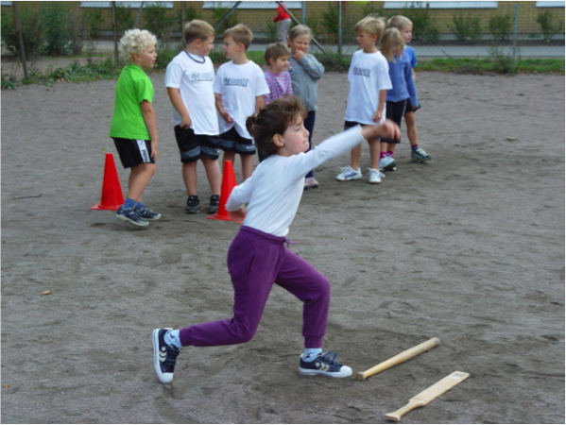

## Fracture registration

Fracture identification was objectively done through our hospital, the only emergency hospital in the city. We identified incident fractures through repeated evaluations of the regional radiographic database that covers the referrals of most non-private health care facilities in the region and all radiographs taken irrespective of the reason for the exam, and all fractures in the studied population were confirmed and classified by one of the co-authors, a senior consultant in orthopedic surgery. If fractures occurred in other regions of the country (about 14%), the majority of these were registered when they were referred to our hospital for a follow-up visit. This method has previously been extensively used and validated at our research center and has been proven valid since it misses less than 3% of the fractures162. We also registered fracture site and trauma level according to the Landin classification14, which has been used in several other pediatric fracture studies20,163. All children starting first grade in the four schools in 1998 were included and followed in the study. The inclusion of children in the first grade continued until 2013. Children who moved out of the region or changed school from the intervention to another school were followed until this event (n=179). This resulted in 1,339 children in the intervention (53.8% boys and 46.2% girls) and 2,195 children in the control group (51.3% boys and 48.7% girls) (**Paper I**). Children with school start 1998 to 2006 (n=1936) were hence followed for seven years, while those with school start 2007 and later (n=1598) were followed until 2013 and thus for a shorter duration than 7 years. This explains why the numbers of participants in paper 1, table 1 were larger during the first evaluated years. This study design resulted in the inclusion of 3,462 individuals in the fracture evaluation in the 1st school year, 3,179 in the 2nd year, 2,856 in the 3rd year, 2,554 in the 4th year, 2,301 in the 5th year, 2,113 in the 6th year and 1,864 in the 7th year. Since only objectively verified fractures were included and this was done through our radiographic archives (and not through questionnaires provided to the children), we were able to include all of the children, that is, no children were excluded from this evaluation.

## Measurements

#### Study subjects

For the in-depth evaluations, including lifestyle factors, anthropometry and musculoskeletal traits, we invited a sub-cohort that included all children in the intervention school with school start 1998 to 2000 and all children in the control schools with school start 1999 to 2000 to participate. In the intervention group 94 of the 105 invited girls and 123 of the 132 invited boys agreed to participate. For the current analyses we excluded two girls and four boys due to diseases or medication that could affect growth, bone health or muscle development and 20 girls and 19 boys as their baseline or follow-up data were inadequate. The corresponding baseline attendance rate in the control group was 64 of the 157 invited girls and 68 of the 170 invited boys and the exclusion rate was one girl due to medication that could affect growth and 18 girls and 21 boys with inadequate follow-up data. This resulted in a sub-cohort of 264 children, 72 girls and 100 boys in the intervention group and 45 girls and 47 boys in the control group (**Papers I–II**) (Figure 10). Another two boys in the intervention group and one girl in the control group were excluded in the bone distribution analysis due to too poor pQCT image quality, rendering 261 children, 72 girls and 98 boys in the intervention group and 44 girls and 47 boys in the control group for that specific analysis (**Paper III**) (Figure 10).

Figure 10. Flow chart describing number of participants included and dropouts for the sub-cohort in Papers I and II and the cohort in Paper III.

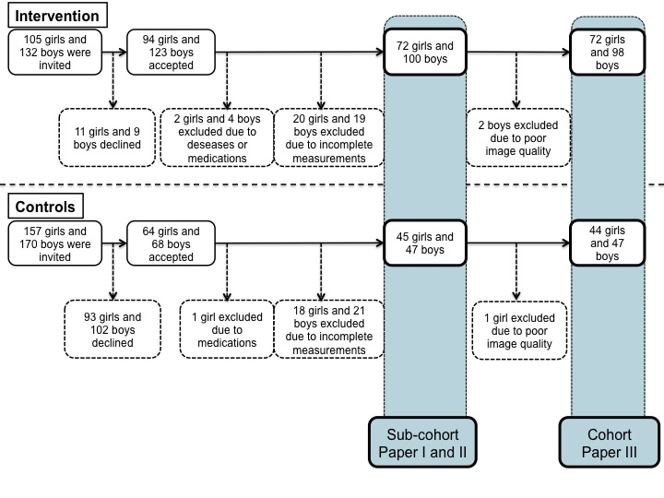

Dropout analysis revealed that there were no differences in baseline age, weight or body mass index (BMI) when comparing the girls who completed the measurements with those who only attended the baseline measurements (Paper II). However, girls who dropped out were taller, had higher BMC and aBMD in the femoral neck, had larger muscle mass (lean mass) and had higher muscle strength in one out of four tests (peak torque 180o/sec). Among boys, no such differences were found. Furthermore, there were no differences in age, height, weight or BMI when data from the grade one compulsory school health examination were analyzed for comparison between the children who participated in the baseline measurements with those who declined164,165. This strengthens the view that the data are generalizable.

#### Anthropometry

Height (Holtan stadiometer) and weight (Avery Berkel HL120 electric scale) were measured repeatedly in all children in the sub-cohort when wearing light clothes but no shoes. Body mass index (BMI) was calculated as weight/height2. Pubertal maturation, as Tanner staging, was assessed by our research nurse at baseline and self-assessed with the assistance of our research nurse if questions arose at follow-up, a validated method166.

#### Lifestyle factors

Lifestyle factors, including current and previous medication, current and previous disease, dietary intake of dairy products, smoking status, alcohol use and organized leisure time physical activity (PA), were assessed through a questionnaire that the children in the sub-cohort answered annually. Total duration of PA was calculated as duration of school physical education together with stated organized leisure time activity (hours/week).

#### Dual-X-Ray Absorptiometry (DXA)

DXA (DPX-L® version 1.3z Lunar, Madison, WI) measurements were used to evaluate bone mass and bone composition (Figure 11). Lean mass and total body and total spine BMC and aBMD were derived from a total body scan, while a hip scan provided BMC and aBMD in the femoral neck. The equipment was calibrated daily with the Lunar Phantom by our research technicians, who also conducted all measurements and software analyses. The precision, estimated as the coefficients of variation (CV) by duplicate measurements in 13 healthy children aged 7–15 years (mean age 10 years) were 1.4–5.2% for BMC, 2.4–2.6% for aBMD and 1.5% for total body lean mass.

Figure 11. A girl in the POP-study is measured by DXA (The Lunar® DPX-L). *Photo presented by courtesy of Bjarne Löfgren.*

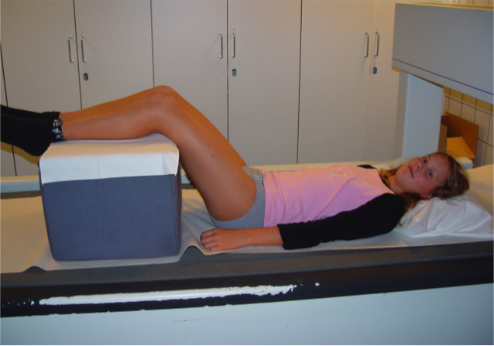

#### Peripheral Quantitative Computed Tomography (pQCT)

pQCT (XCT 2000®; Stratec, Pforzheim, Germany) evaluated the appendicular skeletal properties at the seven-year follow-up (Paper II and III). A left leg scout scan was performed to determine the 14%, 38% and 66% of the tibia length from the distal end of the medial malleolus, after which each site was scanned. The voxel size was set to 0.5 mm, the slice thickness to 2 mm and the scanning speed to 20 mm/second. The manufacturer’s software package (Stratec Medical, Pforzheim, Germany, version 6) in conjunction with edge detection and thresholding steps was used to acquire densitometric and structural parameters of bone and soft tissue. The periosteal surface of the tibia diaphysis was found by using a contour algorithm based on a threshold of 280 mg/cm3 from which total bone area (mm2) was estimated. The polar stress-strain index (SSI, mm3) was derived to estimate diaphyseal bone resistance to torsional loading167. Cortical bone was selected by thresholding at 550 mg/cm3 for the 14% site and 710 mg/cm3 for the 38% and 66% sites, from which cortical area (mm2), cortical density (mg/cm3), and cortical thickness (mm) were derived. Subcutaneous fat cross-sectional area (CSA; cm2) was obtained by selecting the area with thresholds –40 to 40 mg/cm3 hydroxyapatite density. Muscle CSA (cm2) was obtained by subtracting fat CSA and total bone area from the CSA of the total limb. As we measured precision, CV evaluated as duplicate measurements in 13 healthy children aged 7–15 years (mean age 10 years), was 1.7% for trabecular vBMD and 0.5% for cortical vBMD.

Polar distribution (cortical bone mineral mass; mg) and radial distribution (radial vBMD; mg/cm3) of the tibia were estimated using Image J. A threshold of 550 mg/cm3 for the 14% site and 710 mg/cm3 for the 38% and 66% sites with a 3×3 median filtering of the image was used to differentiate the cortical bone from the surrounding soft-tissue and bone marrow. To eliminate partial volume effects, the outermost and innermost layers of cortical pixels were excluded from the analysis. We aligned the bones between individuals according to tibia and fibula marrow center and calculated polar distribution by subdividing the tibia cortex into six sectors around its center of mass with the average bone mass estimated for each sector (Figure 12). Radial distribution was estimated by subdividing the cortex into three concentric rings by first removing all pixels below the threshold of each site from the image and subdividing the remaining cortical bone into three concentric circles with the same thickness. The thickness of the rings varied around the cortex according to the anatomy. The innermost ring is referred to as endocortical, the mid ring as midcortical and the outermost ring as the pericortical (Figure 12).

Figure 12. Polar (left) and radial (right) bone mass distribution168.

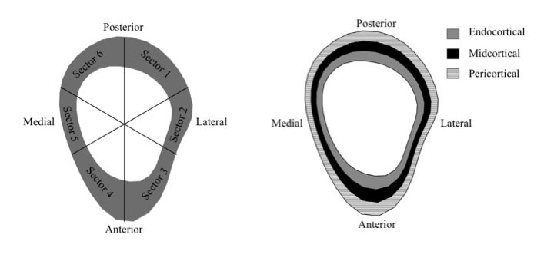

#### Muscle strength

A computerized dynamometer, Biodex (Biodex system III Pro®, with Biodex advantage software), measured the strength of the quadriceps and hamstrings muscles during concentric isokinetic contractions (Figure 13). The participant was seated in the testing chair with the hips flexed to 85° from the anatomical position and the axis of the right knee aligned with the axis of rotation. The participant was secured in the chair according to standard procedure using three belts, crossing the thigh, pelvis and upper torso, as stabilization. If the participant’s upper leg was shorter than the seat, or the lower leg was shorter than the lever arm of the Biodex, pads were used to adjust for the difference to give the correct angle and positioning of the limb. All participants were instructed to place their arms across their chest during the testing. The knee was positioned at 90° of flexion and went through a 75° range of motion, stopping at 15° flexion. Concentric isokinetic knee extension and flexion peak torque were tested at an angular velocity of extension (ex) and flexion (fl) at 60°/second (60°/sec) and 180°/second (180°/sec). Five maximal repetitions at 60°/sec were performed, including both extension and flexion. After 30 seconds’ rest, 10 maximal repetitions at 180°/sec were performed in the same way. The highest peak torque for each of the extension and flexion variables (PTex60, PTfl60, PTex180, PTfl180) were recorded (Nm). All participants received both visual and verbal encouragement during the test82. The precision, evaluated as CV for repeated measurements in 21 children, was 6.6% for PTex60, 12.1% for PTfl60, 12.3% for PTex180 and 9.1% for PTfl180.

Figure 13. A girl in the POP-study is measured by Biodex® (System III Pro) apparatus. *Photo presented by courtesy of Susanna Stenevi Lundgren.*

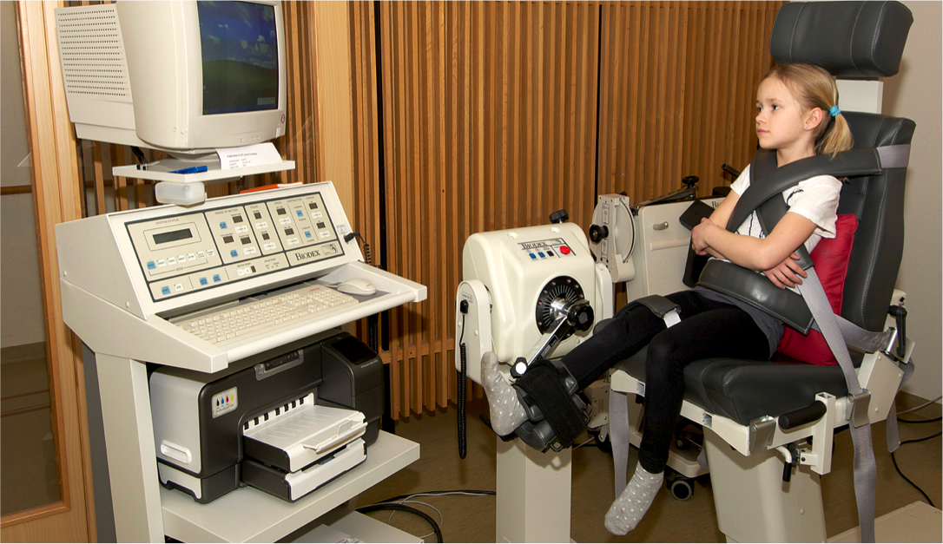

## Academic performance

All schools in Sweden have to retain grade data for all students for at least 15 years. To evaluate the effect of the intervention on academic performance we collected elementary grade scorecard data from 9th grade through the archive of the intervention school. Among the 234 boys and 190 girls starting the intervention school from 1998 to 2003, 49 boys and 37 girls were excluded since they left the intervention school during the study period (and did not have all nine years of intervention), rendering 185 boys and 153 girls finishing the same school from 2007 to 2012 (**Paper IV**).

To be able to identify any changes within the intervention school from the period before the intervention was initiated until after the intervention was initiated, we collected the final grade scorecard data from the 9th grade in all children who started 1st grade in the intervention school from 1994 to 1997 (175 boys and 181 girls). We excluded 20 boys and 41 girls who left the intervention school before graduation in 2003–2006, rendering 155 boys and 140 girls (**Paper IV**).

During these years the 9th and final elementary school grades in Sweden included 16 compulsory school subjects where every subject was graded with the grades Failed (0 points), Passed (10 points), Passed with Distinction (15 points) or Passed with Special Distinction (20 points). The final grade points of these 16 subjects may thus vary from 0 points (p) (no subject with an accepted grade) to 320 p (the highest grade in all subjects). To qualify for national upper secondary school programs the grade Passed in each of the subjects Swedish, English and Mathematics is required.

We then registered final grade points and eligibility for upper secondary school programs in all these children in the intervention school. The same endpoint data for all other Swedish students were retrieved from the Swedish National Agency of Education (Skolverket)169 from 2003 to 2006 (241,089 boys and 230,837 girls) and from 2007 to 2012 (353,439 boys and 336,442 girls) (**Paper IV**).

## Statistical methods

SPSS Statistics for Macintosh, version 20.0 (IBM Corp. Armonk, New York, USA) was used for all statistical analyses. P<0.05 was regarded as statistically significant.

#### Papers I–III

Data are presented as absolute numbers, means ± standard deviations (SD) or means with 95% confidence intervals (95% CI). Annual fracture incidence was estimated and annual incidence rate ratio (IRR) with 95% CI was calculated using Poisson distribution. Spearman’s test was used for correlation between years of intervention and IRR. Lifestyle factors were compared using cross-tabulation with either chi-2 or Fisher’s exact test. Tanner stage distribution between groups was compared using Mann-Whitney U test at both baseline and follow-up. Two-tailed Student’s t-test was used to compare group differences in anthropometrics, PA and baseline musculoskeletal traits. Changes in musculoskeletal traits were estimated as the changes from baseline to follow-up. When comparing musculoskeletal changes between groups, analysis of covariance (ANCOVA) was used with adjustments for age at baseline and absolute baseline value for evaluated trait (Papers I–II). ANCOVA was also used for tibia composition comparisons between groups at follow-up, adjusting for age at follow-up, and for bone distribution parameter comparisons between groups at follow-up, adjusting for age at baseline (Paper III). Fracture-free survival curves were estimated by Kaplan Meier analyses (Paper II).

#### Paper IV

Data are presented as absolute numbers (n), percentages (%), percentage points (pp) or means with 95% confidence intervals (95% CI). No measurement of dispersion is given for national data as these are not drawn from a sample but include all Swedish children (true values). Group differences were evaluated by Pearson’s chi-square test for the eligibility rate and student’s t-test between means for grade points.

# Summary of papers

## Paper I

*Introduction:* Physical activity (PA) in childhood is associated with high bone mass and beneficial neuromuscular function. We investigated whether increased PA is also associated with fracture risk.

*Methods:* Physical education was increased in school for seven years from 60 min/week to 200 min/week in the intervention group, while remaining at 60 min/week in the control group. We registered fractures in all children and measured areal bone mineral density (aBMD; g/cm2) with DXA (femoral neck and total spine) and muscle strength (peak torque for knee extension and flexion; Nm) with computerized dynamometer at baseline and after 7 years. We estimated annual fracture incidence rate ratios (IRR) in the intervention group compared to the control group as well as changes in bone mass and muscle strength. Data are given as mean (95% CI).

*Subjects:* We registered fractures in 3,534 children aged six to eight years at study start, 1,339 in the intervention group and 2,195 in the control group. In a sub-sample of 264 children, 172 in the intervention group and 92 in the control group, we measured musculoskeletal traits.

*Results:* The IRR of fractures decreased with each year of the PA intervention (r=–0.79; p=0.04). During the seventh year IRR was almost halved [IRR 0.52 (0.27, 1.01)]. The intervention group had a statistically significant greater gain in total spine aBMD with a mean group difference of 0.03 (0.00, 0.05) g/cm2 and peak flexion torque 180°/sec with a mean group difference of 5.0 (1.5, 8.6) Nm.

*Conclusion:* Increased PA is associated with decreased fracture risk, probably due in part to beneficial gains in aBMD and muscle strength.

## Paper II

*Introduction:* Physical activity (PA) is associated with high bone mass and beneficial muscle strength in children, but whether the musculoskeletal influence is different in girls and boys is debated. We therefore investigated gender-specific musculoskeletal effects of increased physical activity in children.

*Methods:* In one school we increased the physical education of 72 girls and 100 boys to 200 minutes per week over seven years. In three other schools, 45 girls and 47 boys continued to receive 60 minutes per week. We measured aBMD with DXA and muscle strength with computerized dynamometer at baseline and after seven years and tibial cortical thickness with peripheral quantitative computed tomography (pQCT) after seven years. Data are given as mean (95% CI).

*Subjects:* We assessed musculoskeletal traits in 72 girls and 100 boys in the intervention group and 45 girls and 47 boys in the control group.

*Results:* Girls in the intervention group gained 0.04g/cm2 (0.01–0.08) more total spine aBMD (p<0.05) and 6.2 Nm (1.6, 10.7) more knee flexion strength (p<0.01) than control group girls and had a 0.1 mm (0.0, 0.3) higher tibial cortical thickness at follow-up (p<0.05). Boys in the intervention group gained 7.3 Nm (0.4, 14.2) more knee extension strength (p<0.05) and 7.4 Nm (2.3, 12.4) more knee flexion strength (p<0.01) than the control group boys, but their aBMD was no higher than the control group.

*Conclusion:* A seven-year, population-based moderately intense exercise intervention enhanced gains in spine bone mass in girls and knee muscle strength in both genders.

## Paper III

*Introduction:* Cortical bone mass and density varies across a bone’s length and cross-section, and may be influenced by physical activity. This study evaluated the long-term effects of a pediatric school-based physical activity intervention on tibial cortical bone mass distribution.

*Methods:* Children from one school were provided with 200 minutes of physical education per week (intervention group). Three other schools continued with the standard of 60 minutes per week (control group). Tibial total and cortical area, cortical density, polar stress-strain index (SSI), and the mass and density distribution around the center of mass (polar distribution, mg) and through the bone’s cortex (radial distribution subdivided into endo-, mid-, and pericortical volumetric BMD: mg/cm3) at three sites (14%, 38% and 66%) were assessed using pQCT after 7 years.

*Subjects:* In 72 girls and 98 boys in the intervention group and 44 girls and 47 boys in the control group we assessed cortical bone parameters and distribution.

*Results:* Girls in the intervention group had 2.5% greater cortical thickness and 6.9% greater SSI at the 66% tibia, which was accompanied by significantly greater pericortical volumetric BMD compared to controls (all p<0.05). Region-specific differences in cortical mass were also detected in the anterior, medial and lateral sectors at the 38% and 66% tibial sites. There were no group differences at the 14% tibia site in girls, and no group differences in any of the bone parameters in boys.

*Conclusion:* Additional school-based physical education over seven years was associated with greater tibial structure, strength and region-specific adaptations in cortical bone mass and density distribution in girls, but not in boys.

## Paper IV

*Introduction:* Physical activity (PA) may improve brain development, cognition and concentration and may therefore also improve academic performance.

*Methods:* In the intervention school the level of physical education (PE) was increased from 60 min/week to 200 min/week for students starting first grade in 1998–2003, thus graduating in 2007–2012 after 9 years with the increased level of PE. All other Swedish children continued with the average of 60 min/week of PE during this period. Children graduating in 2003–2006 (before the intervention was initiated), both those in the intervention school and all other Swedish children, had the Swedish standard of 60 min/week of PE. At graduation we registered the proportion of students eligible for upper secondary school and the final grade score (from 0 to 320 grade points). Data are reported as means with 95% confidence intervals for the intervention school but only as means for the all other Swedish children (since this is not a sample).

*Subjects:* We registered academic results in 185 boys and 153 girls in the intervention group graduating in 2007–2012. As controls served all other 353,439 Swedish boys and 336,442 Swedish girls graduating during the same years. We also registered academic results in 155 boys and 140 girls in the same school and in all other 241,089 Swedish boys and 230,837 Swedish girls graduating in 2003–2006 to evaluate academic performance before the intervention was initiated.

*Results:* Before the intervention was initiated, academic performance was similar in the intervention school and all other Swedish boys and girls. With the intervention, the eligibility rate increased in the intervention school for boys by 7.3 (1.4, 13.2) percentage points (pp) and the grades by 13.3 (3.1, 23.5) points, while there was a decrease of 0.8 pp in eligibility rate and an increase by 2.7 points in all other Swedish boys. No group differences were found in girls.

*Conclusion:* Daily school-based PA for nine years improves academic performance in boys, but not in girls.

# General discussion

## Osteoporosis and fracture risk

The most common approach to osteoporosis treatment is to target individuals with osteoporosis or osteopenia, with or without fractures, and use pharmacologic treatment170,171 or to try to reduce other risk factors for fractures in high-risk individuals22,172. Multiple RCTs have shown excellent effect of these treatments regarding future fracture risk reduction173,174. However, to intervene before any prevalent osteoporosis or osteopenia would be even better, and that is the core of the POP study, using PA to early on influence bone mass and muscle strength, two of the most important modifiable risk factors for fracture10,42.

#### During growth

The POP study is the only prospective PA intervention study with fracture as endpoint, and we have previously found similar fracture risks in the intervention and the control cohorts over the entire study period175. Since no PA exposure-time dependent fracture risk was provided in previous reports, a transient increased initial fracture risk due to more falls and traumas in children not used to PA could therefore have obscured long-term fracture-preventive effects. This hypothesis was supported in this thesis and after seven years the fracture risk was halved in the intervention compared to the control cohort.

Furthermore, the inverse correlation between IRR to sustain a fracture and number of years of intervention that we found seems explained by the fact that the higher fracture incidence with each year closer to puberty usually seen16, and seen in our control cohort, did not occur in the intervention group (Paper I, Table 1).

Gender specific fracture analyses would have been preferable, but are not meaningful in our cohort due to low power. However, when gender specifically observing data, the same trend of decreasing IRR for every year of PA intervention as for all individuals (Figure 14) seems to occur for both girls and boys separately (Figure 15 and 16). This strengthens the view that the PA intervention program influences the fracture risk in a positive way, regardless of gender.

Figure 14. Fracture incidence rate ratio (IRR) during 7 years in the 3534 children in the fracture study (Paper I).

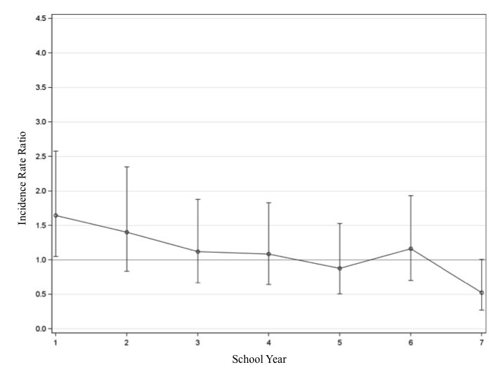

Figure 15. Fracture incidence rate ratio (IRR) during 7 years in the 1688 girls in the fracture study (Paper I).

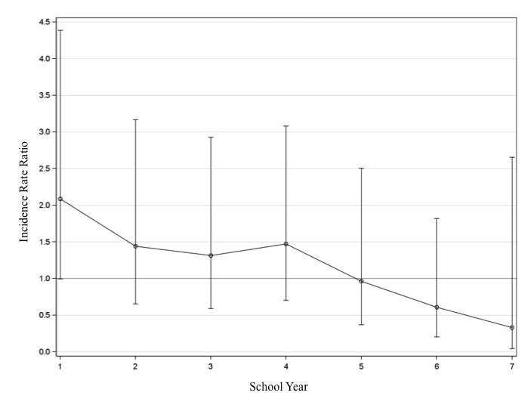

Figure 16. Fracture incidence rate ratio (IRR) during 7 years in the 1846 boys in the fracture study (Paper I).

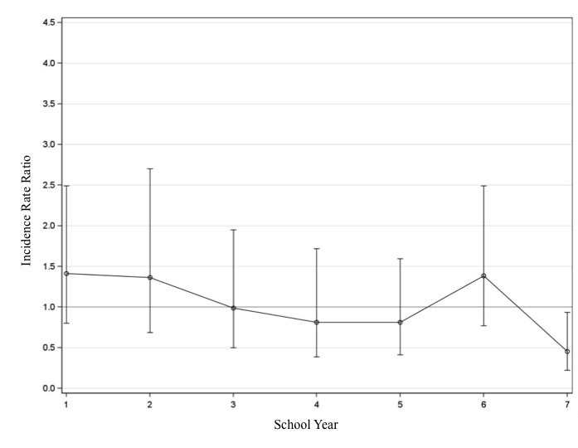

#### In adulthood

Prospective studies have also shown that PA-induced skeletal benefits, at least partly, are retained long-term after reduced activity level176,177 and that fracture incidence in adulthood is low in those with high level of PA during growth126. With this in mind, this thesis shows benefits of PA regarding both bone mass and muscle strength as well as for the primary outcome, fractures. This indicates that PA intervention is a feasible strategy to prevent fractures both during childhood and later in life, and possibly also osteoporosis later in life, thereby decreasing the economic burden on society as well as the individual suffering.

## Musculoskeletal traits

About 20–40% of the variance in bone mass can be explained by environmental factors, the rest is thought to be constituted by genetic factors43,64. By optimizing environmental factors, such as diet and PA, accrual of bone mass and bone size during growth may be improved and age-related bone loss reduced. Since growth is highly varying compared to the more constant and more stable bone attrition after PBM52 and 50% of the bone mass at age 70 years is predicted by PBM52 and 60% of the mature skeletal traits are dependent on the variance before puberty178, the growth period may be the most important period in life to influence the skeleton.

It is common knowledge today that the most potent osteogenic activities include fast novel dynamic loads with high magnitude and high frequency. The skeleton however becomes saturated quite fast with these activities and endurance activities are thereby less effective in this sense179. The activities alter the mechanostat balance system180, so that the mechanical signal is transferred to a biological signal that enhances the function of the osteoblasts, resulting in increased gain in bone mass. Increased aBMD reduces fracture risk independently of fall risk, as a skeleton with high aBMD becomes more resistant to trauma181, and low aBMD has been found in children with distal forearm fractures compared to controls182. Improved muscle strength is known to reduce fall frequency183 and contributes to fewer injurious falls, probably due to improved sensorimotor function116. However, this association has only been found in adults, and whether the same is true for children is, to our knowledge, not known. While there are reports on that exercise during the pre- and peri-pubertal years can enhance bone structure and strength at loaded skeletal sites128,184, there are mixed findings from the limited number of school-based exercise intervention studies that have used pQCT to evaluate exercise-induced changes in bone structure and strength185-189. Nevertheless, several previous cross-sectional studies in children and adolescents62,190 and young athletes191 have reported that higher levels of weight-bearing impact activities were associated with localized cortical adaptations, particularly in the anterior-posterior plane of the mid and proximal tibia. This is in line with other evidence that suggests that the mid-tibial shafts primary loading mode is bending in anterior-posterior plane192 and thus should also be the sites most prone to tibial fracture and therefore also the sites where increased bone mass and bone structure would benefit the fracture risk most.

The greater gain in bone mass in girls with increased PA in our study transformed to a 0.4 standard deviation higher spine aBMD after seven years of intervention, a benefit that according to previous research would convey close to a 25% lower fracture risk193. Both boys and girls with increased PA in our study also had higher gains in muscle strength, which points to an even larger possible fracture risk reduction, since improved neuromuscular function is associated with a low fall risk116,183. This thesis also shows that girls receiving the intervention had greater cortical strength (SSI) and higher mineral mass at the lateral, anterior and anterior-medial sectors of the tibia compared to controls, which may also contribute in decreasing the fracture risk. The region-specific adaptations in the medial and lateral planes may be explained by the fact that our generalized PE intervention included a wide range of activities, such as ball games, running, jumping, and playing, that could have created bending forces in the medial and lateral planes of the tibia.

This thesis supports previous short-term studies that indicate that PA programs improve musculoskeletal development in both genders, but extend the knowledge as we found that girls seemed to benefit more when the program was continued long-term into puberty. This could be because girls in general are less active in their spare time generally and in puberty reduce their PA level to a greater extent than boys194. Indeed, boys in our study were already undertaking a mean of >3 hours per week of physical activity prior to the start of the intervention, hence the additional physical activity may not have been not enough to elicit further bone adaptation. The extra school-based PE would therefore have contributed relatively more to the total duration of PA in girls than in boys.

## Academic performance

PA has been associated with beneficial cognitive achievement92,195-198. This thesis supports this view by showing that increased PA results in increased grades and increased qualification rate to upper secondary school for boys. Furthermore, the increase by 7.3 percentage points should be regarded as an improvement not only of statistical but also clinical relevance, especially since the eligibility rate in Swedish children has decreased during the same period. Since girls before the intervention already had a 95.0% qualification rate and 74.8% of the maximal grades, significantly higher than boys, the potential for them to improve was probably lower than in boys, for girls maybe even enough to be affected by ceiling effects199.

To further analyze the effect of the PA intervention program on academic performance, we compared the intervention school with the control schools from Paper I-III (Table 4 and 5). The results are similar to those comparing the intervention school to all Swedish students (Paper IV). This strengthens our view that the intervention program is the main factor for the positive development in academic performance. However, the fact that the control schools had significantly higher grades and qualification rates before the intervention was initiated is a limitation. Since we had data for all Swedish students, we thus consider the primary analysis included in Paper IV to be of higher interest and research value.

Table 4. Eligibility for upper secondary school and summarized grades for boys in the index school (n=155) and the control school (n=358) during years 2003 – 2006 (abefore the intervention was initiated in the index school) and for boys in the index school (n=185) and the control school (n=448) during years 2007 – 2012 (bwith intervention in the index school).

|  |  |  |  |
| --- | --- | --- | --- |
| **BOYS** | **Students graduatinga** | **Students graduatingb** | **Mean difference between** |
| **2003-2006** | **2007-2012** | **the two periods** |
| **Eligibility for upper secondary school (n (%))** | |  | **percentage points** |
| Index school | 137 (88.4%) | 177 (95.7%) | **7.3 (1.4, 13.2)** |
| Control school | 344 (96.1%) | 432 (96.4%) | 0.3 (-2.3, 3.0) |
| **Summarized grades (mean points (95%CI))** | |  | **points** |
| Index school | 197.7 (189.6, 205.7) | 211.0 (204.4, 217.5) | **13.3 (3.1, 23.5)** |
| Control school | 215.0 (208.9, 221.1) | 223,3 (218.3, 228.3) | **8.3 (0.5, 16.1)** |

Data presented as absolute numbers (n), percentages (%), percentage points (pp) and means with 95% confidence intervals (95% CI). Statistically significant group differences are bolded.

Table 5. Eligibility for upper secondary school and summarized grades for girls in the index school (n=140) and the control school (n=316) during years 2003 – 2006 (abefore the intervention was initiated in the index school) and for girls in the index school (n=153) and the control school (n=410) during years 2007 – 2012 (bwith intervention in the index school).

|  |  |  |  |
| --- | --- | --- | --- |
| **GIRLS** | **Students graduatinga** | **Students graduatingb** | **Mean difference between** |
| **2003-2006** | **2007-2012** | **the two periods** |
| **Eligibility for upper secondary school (n (%))** | |  | **percentage points** |
| Index school | 133 (95.0%) | 146 (95.4%) | 0.4 (-4.5, 5.4) |
| Control school | 306 (96.8%) | 397 (96.8%) | 0.0 (-2.6, 2.6) |
| **Summarized grades (mean points (95%CI))** | |  | **points** |
| Index school | 239.2 (231.3, 247.1) | 233.6 (225.9, 241.3) | -5.6 (-16.6, 5.4) |
| Control school | 231.2 (224.9, 237.5) | 237.7 (232.3, 243.2) | 6.5 (-1.8, 14.8) |

Data presented as absolute numbers (n), percentages (%), percentage points (pp) and means with 95% confidence intervals (95% CI). Statistically significant group differences are bolded.

The amount or intensity of the PA needed to improve cognitive achievement has been discussed157,200 without any clear consensus. Since we in our study exposed all children within a school (not only those who chose to participate) to PA activities on a moderate level, facilitating that every child could participate, our study indicates that increased PA is a feasible strategy to improve academic school results in boys on a population-based level.

Several explanatory hypotheses have been postulated153,195,201, but the reasons for the improved school performance are unclear. There are studies inferring PA to have direct positive effects on the nervous system by increasing brain volume, blood flow to the brain, synaptic plasticity, as well as promoting formation of nerve cells, all involved in different aspects of perception, cognition, memory, and attention147,148,150. There are also studies suggesting PA to have positive effects on psychological parameters such as self-esteem, motivation, social engagement, and communication109, all of importance for learning outcomes. Other studies suggest inferior motor skills to have negative effects in these psychological parameters and delay cognitive development151,152. Furthermore, an association has been shown between PA and attention and academic test results153,154, linking higher levels of PA to the ability to concentrate in the classroom, which also could influence academic performance.

## Strengths of the studies

The strengths of the studies in this thesis include the longitudinal population-based case-control design, the large sample size in the fracture evaluation, the high participation rate in the fracture evaluation and the longest reported intervention follow-up period. It is advantageous that the level of PA in the intervention group was on a moderate level so that all children could participate. Also, the unique technique used to quantify cortical mass and density distribution and the use of the clinically relevant endpoints fractures, average grades and qualification rate to upper secondary school programs must be considered as strengths.

## Limitations of the studies

The main weakness of the studies in this thesis is that they are not randomized controlled trials (RCT). No individual and no school randomization was done prior to study start, but since all schools had the Swedish standard of 60 min/week of PE before the study start and since the schools were community-based, located in the same geographic area with homogenous socioeconomic and ethnic structure and with the children allocated to each school according to their residential address, the risk of selection bias seems low. Other weaknesses include the lack of information regarding when and where the fractures occurred and the lack of registration of non-organized PA. Also, it would have been advantageous to have an objective measurement of the duration of PA throughout the study, e.g. continuous accelerometer-data. Since we only found positive effects in aBMD at the lumbar spine and not the hip and only two of four muscle strength tests in boys and one of four tests in girls, the concern that these positive effects may be related to other differences than the level of PA must be raised. The lower participation rate in the control group (28%) compared to the intervention group (73%) in the musculoskeletal evaluations is also a weakness. However, the view that the data are generalizable is strengthened by the dropout analyses revealing only slight differences between participants and dropouts at baseline in girls and none in boys, and no differences between participants and non-participants in the compulsory grade one school health examination.

In the academic performance evaluation the relatively small intervention group and the absence of background data are limitations since other variables such as ethnicity, socioeconomic status and parental education may affect the outcome. To avoid the influence of any ceiling effect, we would have preferred to conduct the intervention in a school with lower academic achievements in girls, giving them the same potential for improvement as boys in our study.

Other limitations that should be highlighted include the power problem for the fracture endpoint, especially in gender-specific sub-group analyses, the cross-sectional pQCT evaluation and the self-assessment of Tanner staging.

# Conclusions

1. This thesis shows that increasing the amount of physical education in school from approximately 60 min/week to 40 min daily (200 min/week) from school start in children aged 6–9 years **decreases the fracture risk** with every year of extra physical education and **enhances muscle strength**.
2. This program also **improves bone mass and bone strength in girls**, accompanied by region-specific gains in cortical bone mass distribution.
3. Finally, the extra physical education during all nine compulsory school years **improves grades and eligibility to higher education in boys.**

With these conclusions, we call on politicians and decision makers to strongly consider expansion of the physical education school curriculum to include daily physical activity in all Swedish schools to improve the musculoskeletal health and academic performance of future generations.

# 

# Future perspectives

The first three papers in this thesis examine the effect on fracture risk and musculoskeletal health during childhood and adolescence, and since there is a positive effect for the study subject the most intriguing question for the future is whether or not these benefits remain into adulthood and old age and thereby could affect the development of osteoporosis and fragility fractures. To answer this question the POP cohort must be followed further longitudinally into adulthood.

However, a seven-year exercise intervention trial is a push forward regarding the field of school-based physical activity affecting bone mass, bone structure and muscle strength. One of the main findings, decreasing fracture risk with every year of intervention, provides new information about the main outcome from most studies involving bone mass and bone structure, fractures. Since this might be in part due to increased bone mass and muscle strength, fracture risk should be followed further to evaluate if this decrease continues and results in an absolute lower fracture risk with extension of the intervention.

The bone mass distribution sheds light on how and where the increased bone mass is acquired and provides more insight into the physiology of skeletal response to general physical activity. Future studies should include more common fracture sites to evaluate the effect of physical activity on bone remodeling where the effect can be directly transferred to decreasing fractures.

Two major concerns about increasing physical education in school have been the decreased time for other important school subjects and increased school resources needed for such a change in the curriculum. With this school-based intervention we now burst these concerning bubbles by showing that no decrease in grades accompanies such a program and no extra resources are needed. In fact, this thesis now provides strong evidence that increased physical education from school start and throughout elementary school increases grades and eligibility rate for upper secondary school programs in boys. To further investigate the effect of physical activity on academic performance the same cohort should be followed into adulthood to evaluate professional success.

# 

# Summary in Swedish – Populärvetenskaplig sammanfattning

Frakturer är ett stort och dessutom ökande samhällsproblem. Genom att stärka skelettet och muskulaturen kan risken för frakturer minskas. Hög fysisk aktivitet är associerad med hög benmassa, gynnsam skelettstruktur, god muskelfunktion och låg risk att drabbas av frakturer. Fysisk aktivitet skulle därför kunna vara en möjlig strategi för att minska antalet frakturer i samhället. Tidigare forskning har visat att den bästa perioden i livet att påverka sitt skelett genom fysisk aktivitet är pre- och peri-pubertalt. Tidigare studier är dock korta, innefattar små kohorter och baseras främst på inklusion av frivilliga idrottsintresserade barn. Detta gör det svårt att uttala sig om eventuella långtidseffekter samt populationsbaserade effekter, båda viktiga sett ur ett samhällsperspektiv. Skall fysisk aktivitet kunna användas så effektivt som möjligt som frakturprofylax bör den inkludera så många barn som möjligt, helst alla i befolkningen, och ge effekter även vid en träningsnivå som alla barn klarar av att genomföra. Det finns utöver detta även studier som antyder att ökad fysisk aktivitet är associerad med förbättrade kognitiva funktioner, såsom minne och inlärning. Därigenom skulle även akademiska skolresultat kunna påverkas. Detta är av stort intresse eftersom skolresultaten i svensk grundskola, enligt den återkommande PISA-rapporten, de senaste decennierna försämrats. Detta gäller både betyg och andel barn som blir behöriga till gymnasial utbildning. Ökad skolidrott skulle således kunna vara ett sätt att vända denna trend.

Mot denna bakgrund startades Bunkefloprojektet (på engelska förkortad till POP-study), en populationsbaserad prospektiv kontrollerad interventionsstudie som innefattar barn från fyra grundskolor i sydvästra Malmö. En av skolorna utökade ämnet idrott och hälsa från 60 min/vecka till 200 min/vecka (40 min/skoldag). Denna skola fungerade som interventionsskola. Resterande tre skolor fortsatte med 60 min/vecka idrottsundervisning (svensk standard) och fungerade då som kontrollskolor. Vi inkluderade alla 3 534 barn (6–9 år gamla) som började årskurs 1 i någon av dessa skolor år 1998 till 2012 och följde dem i 7 år avseende frakturer. De 264 barn som började år 1998 till 2000 erbjöds vara med i en utökad del av studien där vi följde utveckling av skelett, muskelstyrka och livsstilsfaktorer genom årliga mätningar. För att utvärdera akademiska skolresultat inkluderades alla individer som slutat årskurs 9 år 2003 till 2012 i interventionsskolan. Vi använde även Skolverkets statistikdatabas (Siris) för att inkludera alla individer som slutat årskurs 9 år 2003 till 2012 i hela Sverige som akademisk kontrollgrupp. På detta sätt kunde vi jämföra skolresultaten mellan och inom skolorna före interventionen (skolslut 2003 till 2006) och efter interventionens införande (skolslut 2007 till 2012).

Barnen i interventionsskolan hade jämfört med barnen i kontrollskolorna ökad frakturrisk under det första året efter påbörjad intervention, varefter den relativa frakturrisken sjönk för varje år som interventionen pågick. Vi såg även att flickorna i interventionsgruppen hade förbättrad utveckling av skelettet, i form av ökad benmassa och förändrad struktur jämfört med kontrollgruppen. Någon sådan effekt kunde inte registreras bland pojkarna. Både flickor och pojkar i interventionsgruppen hade förbättrad utveckling av muskelstyrkan jämfört med kontrollgruppen. Pojkarna med extra skolidrott förbättrade sina slutbetyg i nionde klass samt i denna grupp minskade även andelen individer som inte klarade behörighetskraven till gymnasial utbildning. Hos flickorna kunde inga akademiska gynnsamma effekter registreras bland dem med daglig fysisk aktivitet under grundskoleåren.

Ökad skolidrott förefaller således vara en strategi som kan minska den relativa risken för fraktur, förbättra utvecklingen av skelett och muskelstyrka samt öka de akademiska skolprestationerna. Det finns stöd från andra studier att en sådan utveckling i ungdomen kan leda till starkare skelett och bättre muskulatur och därigenom färre frakturer även i vuxenlivet och ålderdomen. Detta gör att vi nu har starkt vetenskapligt underlag att rekommendera daglig idrott i grundskolan för alla barn.

# Acknowledgements

My first encounter with the project that was to be my PhD project was in the office of my supervisor, Professor Magnus Karlsson. I was pitching an idea for a research project I was going to do as part of my medical education. I had it all worked out. I had a plan.

For the next months, Professor Karlsson guided me in my work towards an approved report for my education. He also inspired me to continue with the project and apply for an internship with research possibilities. After that there was no longer any doubt in my mind that this thesis would be completed. Professor Karlsson showed great enthusiasm and leadership over the following years when he inspired me through discussions at the office, email replies during the early hours of Sundays, travels to Åre, Houston, Seattle, Las Vegas and Melbourne and in the end finalizing this thesis.

Back to the plan I had during that first meeting. Well, that was the first and most important thing Professor Karlsson did for me. He told me it was a crappy plan and instead presented a great research project including the schools I myself attended for 9 years to make it even more interesting. My most sincere thanks for that honesty and for all your tutelage.

Research was never part of my plan when studying medicine. Therefore I have many people to thank for getting me started and even more people for helping along the way:

Co-supervisor Dr. Björn Rosengren. Thank you for your relentless endeavor for improvement in our work and our interesting and humorous discussions that really keep me on my toes.

Co-author Professor Rob Daly. Thank you for hosting me in Melbourne and for filling in some of the gaps in knowledge I had concerning difficulties in creating a database and inclusion in a study.

Co-author Dr. Marcus Cöster. Thank you for all the discussions at the office when we tried to outwit Magnus and Björn with new takes on all the data and research questions. You had a great impact in the beginning of my research journey.

Co-author Jan-Åke Nilsson. Thank you for your invaluable statistical advice and discussions.

Co-authors Magnus Dencker, Caroline Karlsson. Thank you for your contributions to the publications.

Co-authors Rachel Duckham and Timo Rantalainen. Thank you for guiding me in the field of cortical distribution, teaching me about study inclusion and taking time out of your schedules to support my research.

Per Gärdsell and Christian Lindén. Thank you for your initiation and planning of the study.

Susanne Jönsson, Christina Nilsson, Eva-Lena Forsberg, Karin Kristensson, Gunnel Nilsson, Karin Önnby, Susanna Stenevi-Lundgren and Karin Ringsberg. Thank you for all you efforts with the measurements.

Lise-Lott Hägg, Lisa Quensel and Lars Jehpsson. Thank you for your help with data management.

Anette Rafsted, Åsa Almgren and Carin Holmberg. Thank you for collecting data, giving logistic support and helping out with organization of the study participants.

All the children, parents, teachers and headmasters from the POP study. Thank you for making this project possible and for your enthusiasm doing so.

My family. Thank you for your limitless support in every aspect of life.

My wife Emma. Thank you for all your love and support, especially when I wander away in my own thoughts.

# References

1. Genant HK, Cooper C, Poor G, et al. Interim report and recommendations of the World Health Organization Task-Force for Osteoporosis. Osteoporosis international 1999;10:259-64.

2. Abrahamsen B, van Staa T, Ariely R, Olson M, Cooper C. Excess mortality following hip fracture: a systematic epidemiological review. Osteoporosis international 2009;20:1633-50.

3. Johnell O, Kanis JA. An estimate of the worldwide prevalence and disability associated with osteoporotic fractures. Osteoporosis international 2006;17:1726-33.

4. Borgstrom F, Zethraeus N, Johnell O, et al. Costs and quality of life associated with osteoporosis-related fractures in Sweden. Osteoporosis international 2006;17:637-50.

5. Rosengren BE, Karlsson MK. The annual number of hip fractures in Sweden will double from year 2002 to 2050: projections based on local and nationwide data. Acta orthopaedica 2014;85:234-7.

6. Rosengren BE, Karlsson M, Petersson I, Englund M. The 21st-century landscape of adult fractures: cohort study of a complete adult regional population. Journal of bone and mineral research 2015;30:535-42.

7. Johnell O, Kanis J. Epidemiology of osteoporotic fractures. Osteoporosis international 2005;16 Suppl 2:S3-7.

8. Kanis JA, Johnell O, Oden A, et al. Long-term risk of osteoporotic fracture in Malmo. Osteoporosis international 2000;11:669-74.

9. Jerrhag D, Englund M, Petersson I, et al. Increasing wrist fracture rates in children may have major implications for future adult fracture burden. Acta orthopaedica 2016;87:296-300.

10. Cummings SR, Nevitt MC, Browner WS, et al. Risk factors for hip fracture in white women. Study of Osteoporotic Fractures Research Group. The New England journal of medicine 1995;332:767-73.

11. De Laet C, Kanis JA, Oden A, et al. Body mass index as a predictor of fracture risk: a meta-analysis. Osteoporosis international 2005;16:1330-8.

12. Prieto-Alhambra D, Premaor MO, Fina Aviles F, et al. The association between fracture and obesity is site-dependent: a population-based study in postmenopausal women. Journal of bone and mineral research 2012;27:294-300.

13. Nathorst Westfelt JA. Environmental factors in childhood accidents. A prospective study in Goteborg, Sweden. Acta paediatrica Scandinavica Supplement 1982;291:1-75.

14. Landin LA. Fracture patterns in children. Analysis of 8,682 fractures with special reference to incidence, etiology and secular changes in a Swedish urban population 1950-1979. Acta orthopaedica Scandinavica Supplementum 1983;202:1-109.

15. Tiderius CJ, Landin L, Duppe H. Decreasing incidence of fractures in children: an epidemiological analysis of 1,673 fractures in Malmo, Sweden, 1993-1994. Acta orthopaedica Scandinavica 1999;70:622-6.

16. Hedstrom EM, Svensson O, Bergstrom U, Michno P. Epidemiology of fractures in children and adolescents. Acta orthopaedica 2010;81:148-53.

17. Goulding A. Risk factors for fractures in normally active children and adolescents. Medicine and sport science 2007;51:102-20.

18. Clark EM, Tobias JH, Ness AR. Association between bone density and fractures in children: a systematic review and meta-analysis. Pediatrics 2006;117:e291-7.

19. Clark EM, Tobias JH, Murray L, Boreham C. Children with low muscle strength are at an increased risk of fracture with exposure to exercise. Journal of musculoskeletal & neuronal interactions 2011;11:196-202.

20. Clark EM, Ness AR, Tobias JH. Vigorous physical activity increases fracture risk in children irrespective of bone mass: a prospective study of the independent risk factors for fractures in healthy children. Journal of bone and mineral research 2008;23:1012-22.

21. Kular J, Tickner J, Chim SM, Xu J. An overview of the regulation of bone remodelling at the cellular level. Clinical biochemistry 2012;45:863-73.

22. Knothe Tate ML, Adamson JR, Tami AE, Bauer TW. The osteocyte. The international journal of biochemistry & cell biology 2004;36:1-8.

23. Duncan RL, Turner CH. Mechanotransduction and the functional response of bone to mechanical strain. Calcified tissue international 1995;57:344-58.

24. Malone AM, Anderson CT, Tummala P, et al. Primary cilia mediate mechanosensing in bone cells by a calcium-independent mechanism. Proceedings of the National Academy of Sciences of the United States of America 2007;104:13325-30.

25. Chao Le Meng Bao EYT, Mark S.K. Chong, Yuchun Liu,, Chan MCaJKY. Advances in Bone Tissue Engineering. Regenerative Medicine and Tissue Engineering, InTech Available from: <http://wwwintechopencom/books/regenerative-medicine-and-tissue-engineering/advances-in-bone-tissue-engineering> 2013.

26. Lanyon LE. Osteocytes, strain detection, bone modeling and remodeling. Calcified tissue international 1993;53 Suppl 1:S102-6; discussion S6-7.

27. Watts NB. Clinical utility of biochemical markers of bone remodeling. Clinical chemistry 1999;45:1359-68.

28. Arnaud CD. Role of dietary calcium in osteoporosis. Advances in internal medicine 1990;35:93-106.

29. Wastney ME, Martin BR, Peacock M, et al. Changes in calcium kinetics in adolescent girls induced by high calcium intake. The Journal of clinical endocrinology and metabolism 2000;85:4470-5.

30. Holick MF. Vitamin D deficiency. The New England journal of medicine 2007;357:266-81.

31. Bischoff-Ferrari HA, Dawson-Hughes B, Staehelin HB, et al. Fall prevention with supplemental and active forms of vitamin D: a meta-analysis of randomised controlled trials. Bmj 2009;339:b3692.

32. Davies JH, Evans BA, Gregory JW. Bone mass acquisition in healthy children. Archives of disease in childhood 2005;90:373-8.

33. Seeman E. Bone quality. Osteoporosis international 2003;14 Suppl 5:S3-7.

34. Mauras N, Rogol AD, Haymond MW, Veldhuis JD. Sex steroids, growth hormone, insulin-like growth factor-1: neuroendocrine and metabolic regulation in puberty. Hormone research 1996;45:74-80.

35. Bailey DA, McKay HA, Mirwald RL, Crocker PR, Faulkner RA. A six-year longitudinal study of the relationship of physical activity to bone mineral accrual in growing children: the university of Saskatchewan bone mineral accrual study. Journal of bone and mineral research 1999;14:1672-9.

36. Bailey DA, Martin AD, McKay HA, Whiting S, Mirwald R. Calcium accretion in girls and boys during puberty: a longitudinal analysis. Journal of bone and mineral research 2000;15:2245-50.

37. Kannus P, Haapasalo H, Sankelo M, et al. Effect of starting age of physical activity on bone mass in the dominant arm of tennis and squash players. Annals of internal medicine 1995;123:27-31.

38. Going SB, Farr JN. Exercise and Bone Macro-architecture: Is Childhood a Window of Opportunity for Osteoporosis Prevention? International journal of body composition research 2010;8:1-9.

39. Bass SL, Eser P, Daly R. The effect of exercise and nutrition on the mechanostat. Journal of musculoskeletal & neuronal interactions 2005;5:239-54.

40. Heaney RP, Abrams S, Dawson-Hughes B, et al. Peak bone mass. Osteoporosis international 2000;11:985-1009.

41. Alwis G, Rosengren B, Stenevi-Lundgren S, Duppe H, Sernbo I, Karlsson MK. Normative dual energy X-ray absorptiometry data in Swedish children and adolescents. Acta paediatrica 2010;99:1091-9.

42. Ahlborg HG, Johnell O, Turner CH, Rannevik G, Karlsson MK. Bone loss and bone size after menopause. The New England journal of medicine 2003;349:327-34.

43. Eisman JA. Genetics of osteoporosis. Endocrine reviews 1999;20:788-804.

44. Kelly PJ, Eisman JA, Sambrook PN. Interaction of genetic and environmental influences on peak bone density. Osteoporosis international 1990;1:56-60.

45. Slemenda CW, Miller JZ, Hui SL, Reister TK, Johnston CC, Jr. Role of physical activity in the development of skeletal mass in children. Journal of bone and mineral research 1991;6:1227-33.

46. Faulkner KG. Bone matters: are density increases necessary to reduce fracture risk? Journal of bone and mineral research 2000;15:183-7.

47. Wasnich RD. Perspective on fracture risk and phalangeal bone mineral density. Journal of clinical densitometry 1998;1:259-68.

48. Mackey DC, Lui LY, Cawthon PM, et al. High-trauma fractures and low bone mineral density in older women and men. Jama 2007;298:2381-8.

49. Assessment of fracture risk and its application to screening for postmenopausal osteoporosis. Report of a WHO Study Group. World Health Organization technical report series 1994;843:1-129.

50. SBU. The Swedish Council on Technology Assessment in Health Care. Oesoporos-prevention, diagnostik och behandling. 2003;1:377.

51. Hernandez CJ, Beaupre GS, Carter DR. A theoretical analysis of the relative influences of peak BMD, age-related bone loss and menopause on the development of osteoporosis. Osteoporosis international 2003;14:843-7.

52. Hui SL, Slemenda CW, Johnston CC, Jr. The contribution of bone loss to postmenopausal osteoporosis. Osteoporosis international 1990;1:30-4.

53. Beck TJ, Oreskovic TL, Stone KL, et al. Structural adaptation to changing skeletal load in the progression toward hip fragility: the study of osteoporotic fractures. Journal of bone and mineral research 2001;16:1108-19.

54. Seeman E. Bone quality: the material and structural basis of bone strength. Journal of bone and mineral metabolism 2008;26:1-8.

55. Duan Y, Parfitt A, Seeman E. Vertebral bone mass, size, and volumetric density in women with spinal fractures. Journal of bone and mineral research 1999;14:1796-802.

56. Seeman E, Duan Y, Fong C, Edmonds J. Fracture site-specific deficits in bone size and volumetric density in men with spine or hip fractures. Journal of bone and mineral research 2001;16:120-7.

57. Rantalainen T, Nikander R, Heinonen A, Daly RM, Sievanen H. An open source approach for regional cortical bone mineral density analysis. Journal of musculoskeletal & neuronal interactions 2011;11:243-8.

58. Atkinson PJ, Weatherell JA. Variation in the density of the femoral diaphysis with age. The Journal of bone and joint surgery British volume 1967;49:781-8.

59. Robling AG, Hinant FM, Burr DB, Turner CH. Improved bone structure and strength after long-term mechanical loading is greatest if loading is separated into short bouts. Journal of bone and mineral research 2002;17:1545-54.

60. Seeman E. Structural basis of growth-related gain and age-related loss of bone strength. Rheumatology 2008;47 Suppl 4:iv2-8.

61. Bousson V, Meunier A, Bergot C, et al. Distribution of intracortical porosity in human midfemoral cortex by age and gender. Journal of bone and mineral research 2001;16:1308-17.

62. Rantalainen T, Weeks BK, Nogueira RC, Beck BR. Effects of bone-specific physical activity, gender and maturity on tibial cross-sectional bone material distribution: a cross-sectional pQCT comparison of children and young adults aged 5-29 years. Bone 2015;72:101-8.

63. Howard GM, Nguyen TV, Harris M, Kelly PJ, Eisman JA. Genetic and environmental contributions to the association between quantitative ultrasound and bone mineral density measurements: a twin study. Journal of bone and mineral research 1998;13:1318-27.

64. Pocock NA, Eisman JA, Hopper JL, Yeates MG, Sambrook PN, Eberl S. Genetic determinants of bone mass in adults. A twin study. The Journal of clinical investigation 1987;80:706-10.

65. Tremollieres FA, Pouilles JM, Drewniak N, Laparra J, Ribot CA, Dargent-Molina P. Fracture risk prediction using BMD and clinical risk factors in early postmenopausal women: sensitivity of the WHO FRAX tool. Journal of bone and mineral research 2010;25:1002-9.

66. Bianchi ML, Baim S, Bishop NJ, et al. Official positions of the International Society for Clinical Densitometry (ISCD) on DXA evaluation in children and adolescents. Pediatric nephrology 2010;25:37-47.

67. Bone density measurement--a systematic review. A report from SBU, the Swedish Council on Technology Assessment in Health Care. Journal of internal medicine Supplement 1997;739:1-60.

68. Laskey MA. Dual-energy X-ray absorptiometry and body composition. Nutrition 1996;12:45-51.

69. Faulkner KG, McClung MR. Quality control of DXA instruments in multicenter trials. Osteoporosis international 1995;5:218-27.

70. Berger A. Bone mineral density scans. Bmj 2002;325:484.

71. Damilakis J, Adams JE, Guglielmi G, Link TM. Radiation exposure in X-ray-based imaging techniques used in osteoporosis. European radiology 2010;20:2707-14.

72. Svendsen OL, Hassager C, Skodt V, Christiansen C. Impact of soft tissue on in vivo accuracy of bone mineral measurements in the spine, hip, and forearm: a human cadaver study. Journal of bone and mineral research 1995;10:868-73.

73. Patel R, Blake GM, Rymer J, Fogelman I. Long-term precision of DXA scanning assessed over seven years in forty postmenopausal women. Osteoporosis international 2000;11:68-75.

74. Ashby RL, Ward KA, Roberts SA, Edwards L, Mughal MZ, Adams JE. A reference database for the Stratec XCT-2000 peripheral quantitative computed tomography (pQCT) scanner in healthy children and young adults aged 6-19 years. Osteoporosis international 2009;20:1337-46.

75. Huxley AF. Muscular contraction. The Journal of physiology 1974;243:1-43.

76. Malina RM, Eisenmann JC, Cumming SP, Ribeiro B, Aroso J. Maturity-associated variation in the growth and functional capacities of youth football (soccer) players 13-15 years. European journal of applied physiology 2004;91:555-62.

77. Van Waarde A, Van den Thillart G, Erkelens C, Addink A, Lugtenburg J. Functional coupling of glycolysis and phosphocreatine utilization in anoxic fish muscle. An in vivo 31P NMR study. The Journal of biological chemistry 1990;265:914-23.

78. Medbo JI, Mohn AC, Tabata I, Bahr R, Vaage O, Sejersted OM. Anaerobic capacity determined by maximal accumulated O2 deficit. Journal of applied physiology 1988;64:50-60.

79. Ingalls CP. Nature vs. nurture: can exercise really alter fiber type composition in human skeletal muscle? Journal of applied physiology 2004;97:1591-2.

80. Rowland T. Developmental exercise physiology. 1996:215-30.

81. Daly RM, Rosengren BE, Alwis G, Ahlborg HG, Sernbo I, Karlsson MK. Gender specific age-related changes in bone density, muscle strength and functional performance in the elderly: a-10 year prospective population-based study. BMC geriatrics 2013;13:71.

82. De Ste Croix M, Deighan M, Armstrong N. Assessment and interpretation of isokinetic muscle strength during growth and maturation. Sports medicine 2003;33:727-43.

83. Strong WB, Malina RM, Blimkie CJ, et al. Evidence based physical activity for school-age youth. The Journal of pediatrics 2005;146:732-7.

84. Gaines JM, Talbot LA. Isokinetic strength testing in research and practice. Biological research for nursing 1999;1:57-64.

85. Jones, Stratton G. Muscle function assessment in children. Acta paediatrica 2000;89:753-61.

86. Baker D, Wilson G, Carlyon B. Generality versus specificity: a comparison of dynamic and isometric measures of strength and speed-strength. European journal of applied physiology and occupational physiology 1994;68:350-5.

87. Society AC. Brain and Spinal Cord Tumors in Adults. 2010.

88. Barkley R. ADHD and the nature of self-control. . The Guilford Press 1997.

89. Duvner T. ADHD. Liber 1997.

90. Farooq M, Chaundhry A, Shafiq M, Berhanu G. Factors Affecting Students´ Quality of Academic Performance: A Case of Secondary School Level. Journal of Quality and Technology Management 2011;7:1-14.

91. Bunketorp Kall L, Malmgren H, Olsson E, Linden T, Nilsson M. Effects of a Curricular Physical Activity Intervention on Children's School Performance, Wellness, and Brain Development. The Journal of school health 2015;85:704-13.

92. Burrows R, Correa-Burrows P, Orellana Y, Almagia A, Lizana P, Ivanovic D. Scheduled physical activity is associated with better academic performance in Chilean school-age children. Journal of physical activity & health 2014;11:1600-6.

93. Organisation for Co-operation and Development. PISA 2009. Results: Learning trends: Changes in Student Performance Since 2000 OECD Publishing, Paris Available from: <http://dxdoiorg/101787/9789264091580-en> 2010.

94. York T, Gibson C, Rankin S. Defining and Measuring Academic Success. Practical Assessment, Research & Evaluation 2015;20.

95. Swedish National Agency for Education. . Grading systems Available from: <http://wwwskolverketse/bedomning/betyg/tidigare-betygssystem-146885> 2014.

96. Swedish National Agency for Education. . Final Grades in Mandatory School, Spring 2015 Available from: <http://wwwskolverketse/publikationer?id=3528> 2015.

97. Organisation for Co-operation and Development. . Improving schools in Sweden: an OECD perspective OECD Publishing, Paris Available from: <http://wwwoecdorg/edu/school/Improving-Schools-in-Swedenpdf> 2015.

98. Ekman R, Dolan T. Kunskap om hjärnan kan ge bättre skola [Knowledge about the brain can lead to a better school]. Sydsvenska Dagbladet 21 October 2010: A5 2010.

99. Caspersen CJ, Powell KE, Christenson GM. Physical activity, exercise, and physical fitness: definitions and distinctions for health-related research. Public health reports 1985;100:126-31.

100. Andersen LB, Harro M, Sardinha LB, et al. Physical activity and clustered cardiovascular risk in children: a cross-sectional study (The European Youth Heart Study). Lancet 2006;368:299-304.

101. Lee IM, Rexrode KM, Cook NR, Manson JE, Buring JE. Physical activity and coronary heart disease in women: is "no pain, no gain" passe? Jama 2001;285:1447-54.

102. Lee IM, Skerrett PJ. Physical activity and all-cause mortality: what is the dose-response relation? Medicine and science in sports and exercise 2001;33:S459-71; discussion S93-4.

103. Services). UUSDoHaH. Physical Activity and Health: A Report of the Surgeon General, U.S. Dept. of Health and Human Services, Centers for Disease Control and Prevention, Atlanta, GA, USA. 2008.

104. Chinapaw MJ, Mokkink LB, van Poppel MN, van Mechelen W, Terwee CB. Physical activity questionnaires for youth: a systematic review of measurement properties. Sports medicine 2010;40:539-63.

105. Helmerhorst HJ, Brage S, Warren J, Besson H, Ekelund U. A systematic review of reliability and objective criterion-related validity of physical activity questionnaires. The international journal of behavioral nutrition and physical activity 2012;9:103.

106. Schoeller DA, van Santen E. Measurement of energy expenditure in humans by doubly labeled water method. Journal of applied physiology: respiratory, environmental and exercise physiology 1982;53:955-9.

107. Keytel LR, Goedecke JH, Noakes TD, et al. Prediction of energy expenditure from heart rate monitoring during submaximal exercise. Journal of sports sciences 2005;23:289-97.

108. Tudor-Locke C, Williams JE, Reis JP, Pluto D. Utility of pedometers for assessing physical activity: construct validity. Sports medicine 2004;34:281-91.

109. Committee on Physical Activity and Physical Education in the School Environment. Food and Nutrition Board; Institute of Medicine; Kohl HW III, Cook HD, editors Educating the Student Body: Taking Physical Activity and Physical Education to School Washington (DC): National Academies Press (US); 2013 Oct 30 Available from: <http://wwwncbinlmnihgov/books/NBK201500/> doi: 1017226/18314 2013.

110. Ericsson I. Thesis: Motor skills, attention and academic achievements - An intervention study in school year 1-3. School of Education, Malmö University 2003.

111. European Commision E, Eurodyce. . Physical Education and Sport at School in Europe 2013.

112. Tammelin T. A review of longitudinal studies on youth predictors of adulthood physical activity. International journal of adolescent medicine and health 2005;17:3-12.

113. Taylor WC, Blair SN, Cummings SS, Wun CC, Malina RM. Childhood and adolescent physical activity patterns and adult physical activity. Medicine and science in sports and exercise 1999;31:118-23.

114. Telama R, Yang X, Viikari J, Valimaki I, Wanne O, Raitakari O. Physical activity from childhood to adulthood: a 21-year tracking study. American journal of preventive medicine 2005;28:267-73.

115. Gardner MM, Robertson MC, Campbell AJ. Exercise in preventing falls and fall related injuries in older people: a review of randomised controlled trials. British journal of sports medicine 2000;34:7-17.

116. Lord SR, Ward JA, Williams P, Strudwick M. The effect of a 12-month exercise trial on balance, strength, and falls in older women: a randomized controlled trial. Journal of the American Geriatrics Society 1995;43:1198-206.

117. Shumway-Cook A, Gruber W, Baldwin M, Liao S. The effect of multidimensional exercises on balance, mobility, and fall risk in community-dwelling older adults. Physical therapy 1997;77:46-57.

118. Wolfson L, Whipple R, Derby C, et al. Balance and strength training in older adults: intervention gains and Tai Chi maintenance. Journal of the American Geriatrics Society 1996;44:498-506.

119. Coutinho ES, Fletcher A, Bloch KV, Rodrigues LC. Risk factors for falls with severe fracture in elderly people living in a middle-income country: a case control study. BMC geriatrics 2008;8:21.

120. Cameron ID, Gillespie LD, Robertson MC, et al. Interventions for preventing falls in older people in care facilities and hospitals. The Cochrane database of systematic reviews 2012;12:CD005465.

121. Nelson HD, Haney EM, Dana T, Bougatsos C, Chou R. Screening for osteoporosis: an update for the U.S. Preventive Services Task Force. Annals of internal medicine 2010;153:99-111.

122. Siris ES, Baim S, Nattiv A. Primary care use of FRAX: absolute fracture risk assessment in postmenopausal women and older men. Postgraduate medicine 2010;122:82-90.

123. Lim LS, Hoeksema LJ, Sherin K, Committee APP. Screening for osteoporosis in the adult U.S. population: ACPM position statement on preventive practice. American journal of preventive medicine 2009;36:366-75.

124. Lim SY, Lim JH, Nguyen D, et al. Screening for osteoporosis in men aged 70 years and older in a primary care setting in the United States. American journal of men's health 2013;7:350-4.

125. Cooper C, Dennison EM, Leufkens HG, Bishop N, van Staa TP. Epidemiology of childhood fractures in Britain: a study using the general practice research database. Journal of bone and mineral research 2004;19:1976-81.

126. Tveit M, Rosengren BE, Nyquist F, Nilsson JA, Karlsson MK. Former male elite athletes have lower incidence of fragility fractures than expected. Medicine and science in sports and exercise 2013;45:405-10.

127. Frost HM. Bone "mass" and the "mechanostat": a proposal. The Anatomical record 1987;219:1-9.

128. Daly RM. The effect of exercise on bone mass and structural geometry during growth. Medicine and sport science 2007;51:33-49.

129. Lanyon LE. Control of bone architecture by functional load bearing. Journal of bone and mineral research 1992;7 Suppl 2:S369-75.

130. Rubin CT, Lanyon LE. Regulation of bone mass by mechanical strain magnitude. Calcified tissue international 1985;37:411-7.

131. Leigey D, Irrgang J, Francis K, Cohen P, Wright V. Participation in high-impact sports predicts bone mineral density in senior olympic athletes. Sports health 2009;1:508-13.

132. Hetland ML, Haarbo J, Christiansen C. Low bone mass and high bone turnover in male long distance runners. The Journal of clinical endocrinology and metabolism 1993;77:770-5.

133. Nikander R, Sievanen H, Heinonen A, Kannus P. Femoral neck structure in adult female athletes subjected to different loading modalities. Journal of bone and mineral research 2005;20:520-8.

134. Kannus P, Jarvinen M, Sievanen H, Oja P, Vuori I. Osteoporosis in men with a history of tibial fracture. Journal of bone and mineral research 1994;9:423-9.

135. Schoenau E, Frost HM. The "muscle-bone unit" in children and adolescents. Calcified tissue international 2002;70:405-7.

136. Daly RM, Saxon L, Turner CH, Robling AG, Bass SL. The relationship between muscle size and bone geometry during growth and in response to exercise. Bone 2004;34:281-7.

137. Baxter-Jones AD, Eisenmann JC, Mirwald RL, Faulkner RA, Bailey DA. The influence of physical activity on lean mass accrual during adolescence: a longitudinal analysis. Journal of applied physiology 2008;105:734-41.

138. Daly RM, Bass SL. Lifetime sport and leisure activity participation is associated with greater bone size, quality and strength in older men. Osteoporosis international 2006;17:1258-67.

139. Nilsson A, Anderssen SA, Andersen LB, et al. Between- and within-day variability in physical activity and inactivity in 9- and 15-year-old European children. Scandinavian journal of medicine & science in sports 2009;19:10-8.

140. Marini M. The Exercised Skeletal Muscle: A review. . European Translational Myology - Myology reviews 2010.

141. Garcia-Pallares J, Izquierdo M. Strategies to optimize concurrent training of strength and aerobic fitness for rowing and canoeing. Sports medicine 2011;41:329-43.

142. Holloszy JO, Coyle EF. Adaptations of skeletal muscle to endurance exercise and their metabolic consequences. Journal of applied physiology: respiratory, environmental and exercise physiology 1984;56:831-8.

143. Jones TE, Baar K, Ojuka E, Chen M, Holloszy JO. Exercise induces an increase in muscle UCP3 as a component of the increase in mitochondrial biogenesis. American journal of physiology Endocrinology and metabolism 2003;284:E96-101.

144. Rogol AD, Clark PA, Roemmich JN. Growth and pubertal development in children and adolescents: effects of diet and physical activity. The American journal of clinical nutrition 2000;72:521S-8S.

145. Hogler W, Blimkie CJ, Cowell CT, et al. Sex-specific developmental changes in muscle size and bone geometry at the femoral shaft. Bone 2008;42:982-9.

146. Behringer M, Vom Heede A, Yue Z, Mester J. Effects of resistance training in children and adolescents: a meta-analysis. Pediatrics 2010;126:e1199-210.

147. Neeper SA, Gomez-Pinilla F, Choi J, Cotman C. Exercise and brain neurotrophins. Nature 1995;373:109.

148. Swain RA, Harris AB, Wiener EC, et al. Prolonged exercise induces angiogenesis and increases cerebral blood volume in primary motor cortex of the rat. Neuroscience 2003;117:1037-46.

149. Colcombe SJ, Erickson KI, Scalf PE, et al. Aerobic exercise training increases brain volume in aging humans. The journals of gerontology Series A, Biological sciences and medical sciences 2006;61:1166-70.

150. Winter B, Breitenstein C, Mooren FC, et al. High impact running improves learning. Neurobiology of learning and memory 2007;87:597-609.

151. Cratty B. Coordination Problems Among Learning Disabled, In B. Cratty & R. Goldman (Eds.). Learning Disabilities, Contemporary Viewpoints Amsterdam: Harwood Academic Publishers 1997.

152. Gjesing G. Kropumulige Unger. . Köpenhamn: DHLs förlag 1997.

153. Hillman CH, Erickson KI, Kramer AF. Be smart, exercise your heart: exercise effects on brain and cognition. Nature reviews Neuroscience 2008;9:58-65.

154. Pontifex MB, Scudder MR, Drollette ES, Hillman CH. Fit and vigilant: the relationship between poorer aerobic fitness and failures in sustained attention during preadolescence. Neuropsychology 2012;26:407-13.

155. Singh A, Uijtdewilligen L, Twisk JW, van Mechelen W, Chinapaw MJ. Physical activity and performance at school: a systematic review of the literature including a methodological quality assessment. Archives of pediatrics & adolescent medicine 2012;166:49-55.

156. Rasberry CN, Lee SM, Robin L, et al. The association between school-based physical activity, including physical education, and academic performance: a systematic review of the literature. Preventive medicine 2011;52 Suppl 1:S10-20.

157. Donnelly JE, Lambourne K. Classroom-based physical activity, cognition, and academic achievement. Preventive medicine 2011;52 Suppl 1:S36-42.

158. Hobart JA, Smucker DR. The female athlete triad. American family physician 2000;61:3357-64, 67.

159. Dencker M, Thorsson O, Karlsson MK, et al. Daily physical activity related to body fat in children aged 8-11 years. The Journal of pediatrics 2006;149:38-42.

160. Dencker M, Thorsson O, Linden C, Wollmer P, Andersen LB, Karlsson MK. BMI and objectively measured body fat and body fat distribution in prepubertal children. Clinical physiology and functional imaging 2007;27:12-6.

161. Gustafsson P, Thernlund G, Besjakov J, Karlsson MK, Ericsson I, Svedin CG. ADHD symptoms and maturity--a study in primary school children. Acta paediatrica 2008;97:233-8.

162. Jonsson B, Gardsell P, Johnell O, Redlund-Johnell I, Sernbo I. Remembering fractures: fracture registration and proband recall in southern Sweden. Journal of epidemiology and community health 1994;48:489-90.

163. Clark BJ, Hamilton DA, Whishaw IQ. Motor activity (exploration) and formation of home bases in mice (C57BL/6) influenced by visual and tactile cues: modification of movement distribution, distance, location, and speed. Physiology & behavior 2006;87:805-16.

164. Linden C, Ahlborg HG, Besjakov J, Gardsell P, Karlsson MK. A school curriculum-based exercise program increases bone mineral accrual and bone size in prepubertal girls: two-year data from the pediatric osteoporosis prevention (POP) study. Journal of bone and mineral research 2006;21:829-35.

165. Linden C, Alwis G, Ahlborg H, et al. Exercise, bone mass and bone size in prepubertal boys: one-year data from the pediatric osteoporosis prevention study. Scandinavian journal of medicine & science in sports 2007;17:340-7.

166. Duke PM, Litt IF, Gross RT. Adolescents' self-assessment of sexual maturation. Pediatrics 1980;66:918-20.

167. Schoenau E, Neu CM, Rauch F, Manz F. The development of bone strength at the proximal radius during childhood and adolescence. The Journal of clinical endocrinology and metabolism 2001;86:613-8.

168. Fritz J, Duckham RL, Rantalainen T, Rosengren BE, Karlsson MK, Daly RM. Influence of a School-based Physical Activity Intervention on Cortical Bone Mass Distribution: A 7-year Intervention Study. Calcified tissue international 2016;99:443-53.

169. Swedish National Agency for Education. siris.skolverket.se2009.

170. Compston J, Bowring C, Cooper A, et al. Diagnosis and management of osteoporosis in postmenopausal women and older men in the UK: National Osteoporosis Guideline Group (NOGG) update 2013. Maturitas 2013;75:392-6.

171. Kling JM, Clarke BL, Sandhu NP. Osteoporosis prevention, screening, and treatment: a review. Journal of women's health 2014;23:563-72.

172. Lanyon LE. Functional strain as a determinant for bone remodeling. Calcified tissue international 1984;36 Suppl 1:S56-61.

173. Geusens P. Bisphosphonates for postmenopausal osteoporosis: determining duration of treatment. Current osteoporosis reports 2009;7:12-7.

174. Mulder JE, Kolatkar NS, LeBoff MS. Drug insight: Existing and emerging therapies for osteoporosis. Nature clinical practice Endocrinology & metabolism 2006;2:670-80.

175. Detter F, Rosengren BE, Dencker M, Lorentzon M, Nilsson JA, Karlsson MK. A Six-Year Exercise Program Improves Skeletal Traits without Affecting Fracture Risk - a Prospective Controlled Study in 2621 Children. Journal of bone and mineral research 2014.

176. Tveit M, Rosengren BE, Nilsson JA, Ahlborg HG, Karlsson MK. Bone mass following physical activity in young years: a mean 39-year prospective controlled study in men. Osteoporosis international 2013;24:1389-97.

177. Erlandson MC, Kontulainen SA, Chilibeck PD, Arnold CM, Faulkner RA, Baxter-Jones AD. Higher premenarcheal bone mass in elite gymnasts is maintained into young adulthood after long-term retirement from sport: a 14-year follow-up. Journal of bone and mineral research 2012;27:104-10.

178. Loro ML, Sayre J, Roe TF, Goran MI, Kaufman FR, Gilsanz V. Early identification of children predisposed to low peak bone mass and osteoporosis later in life. The Journal of clinical endocrinology and metabolism 2000;85:3908-18.

179. Rubin CT, Lanyon LE. Kappa Delta Award paper. Osteoregulatory nature of mechanical stimuli: function as a determinant for adaptive remodeling in bone. Journal of orthopaedic research : official publication of the Orthopaedic Research Society 1987;5:300-10.

180. Frost HM, Ferretti JL, Jee WS. Perspectives: some roles of mechanical usage, muscle strength, and the mechanostat in skeletal physiology, disease, and research. Calcified tissue international 1998;62:1-7.

181. Melton LJ, 3rd, Atkinson EJ, O'Fallon WM, Wahner HW, Riggs BL. Long-term fracture prediction by bone mineral assessed at different skeletal sites. Journal of bone and mineral research : the official journal of the American Society for Bone and Mineral Research 1993;8:1227-33.

182. Goulding A, Grant AM, Williams SM. Bone and body composition of children and adolescents with repeated forearm fractures. Journal of bone and mineral research : the official journal of the American Society for Bone and Mineral Research 2005;20:2090-6.

183. Yau DT, Chung RC, Pang MY. Knee muscle strength and visual acuity are the most important modifiable predictors of falls in patients after hip fracture surgery: a prospective study. Calcified tissue international 2013;92:287-95.

184. Tan VP, Macdonald HM, Kim S, et al. Influence of physical activity on bone strength in children and adolescents: a systematic review and narrative synthesis. Journal of bone and mineral research 2014;29:2161-81.

185. Macdonald HM, Kontulainen SA, Khan KM, McKay HA. Is a school-based physical activity intervention effective for increasing tibial bone strength in boys and girls? Journal of bone and mineral research 2007;22:434-46.

186. Macdonald HM, Cooper DM, McKay HA. Anterior-posterior bending strength at the tibial shaft increases with physical activity in boys: evidence for non-uniform geometric adaptation. Osteoporosis international 2009;20:61-70.

187. Bradney M, Pearce G, Naughton G, et al. Moderate exercise during growth in prepubertal boys: changes in bone mass, size, volumetric density, and bone strength: a controlled prospective study. Journal of bone and mineral research 1998;13:1814-21.

188. Anliker E, Dick C, Rawer R, Toigo M. Effects of jumping exercise on maximum ground reaction force and bone in 8- to 12-year-old boys and girls: a 9-month randomized controlled trial. Journal of musculoskeletal & neuronal interactions 2012;12:56-67.

189. Daly RM, Ducher G, Hill B, et al. Effects of a Specialist-Led, School Physical Education Program on Bone Mass, Structure, and Strength in Primary School Children: A 4-Year Cluster Randomized Controlled Trial. Journal of bone and mineral research 2016;31:289-98.

190. Duckham RL, Rantalainen T, Ducher G, et al. Effects of Habitual Physical Activity and Fitness on Tibial Cortical Bone Mass, Structure and Mass Distribution in Pre-pubertal Boys and Girls: The Look Study. Calcified tissue international 2016.

191. Rantalainen T, Nikander R, Daly RM, Heinonen A, Sievanen H. Exercise loading and cortical bone distribution at the tibial shaft. Bone 2011;48:786-91.

192. Peterman MM, Hamel AJ, Cavanagh PR, Piazza SJ, Sharkey NA. In vitro modeling of human tibial strains during exercise in micro-gravity. Journal of biomechanics 2001;34:693-8.

193. Cummings SR, Marcus R, Palermo L, Ensrud KE, Genant HK. Does estimating volumetric bone density of the femoral neck improve the prediction of hip fracture? A prospective study. Study of Osteoporotic Fractures Research Group. Journal of bone and mineral research 1994;9:1429-32.

194. Goran MI, Gower BA, Nagy TR, Johnson RK. Developmental changes in energy expenditure and physical activity in children: evidence for a decline in physical activity in girls before puberty. Pediatrics 1998;101:887-91.

195. Ericsson I, Karlsson MK. Motor skills and school performance in children with daily physical education in school--a 9-year intervention study. Scandinavian journal of medicine & science in sports 2014;24:273-8.

196. Aberg MA, Pedersen NL, Toren K, et al. Cardiovascular fitness is associated with cognition in young adulthood. Proceedings of the National Academy of Sciences of the United States of America 2009;106:20906-11.

197. Kall LB, Nilsson M, Linden T. The impact of a physical activity intervention program on academic achievement in a Swedish elementary school setting. The Journal of school health 2014;84:473-80.

198. Carlson SA, Fulton JE, Lee SM, et al. Physical education and academic achievement in elementary school: data from the early childhood longitudinal study. American journal of public health 2008;98:721-7.

199. Po ALW. Dictionary of Evidence-based Medicine. Radcliffe Publishing, ISBN 978-1-85775-305-9 1998:20.

200. Coe DP, Pivarnik JM, Womack CJ, Reeves MJ, Malina RM. Effect of physical education and activity levels on academic achievement in children. Medicine and science in sports and exercise 2006;38:1515-9.

201. Schneider S, Vogt T, Frysch J, Guardiera P, Struder HK. School sport--a neurophysiological approach. Neuroscience letters 2009;467:131-4.